Student’s surname Name

/ / /

Sezione 4: PROCESS REGULATION AND CONTROL

Feedback control
A concentrated solution must be mixed with a diluent in order to reduce the concentration of the solute to a given value. To this aim, a composition controller regulates the diluent flow rate. The composition is measured by an offline gas chromatograph (see figure).
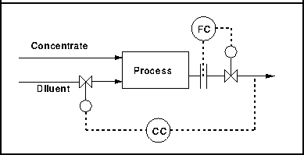
The correspondent block diagram for the feedback control is reported in the following figure:

- Find the correct correspondences (use the letters A to F) for:
A concentration set point
B controller output
C diluent flow rate
D concentrated solution flow rate
E product flow rate
F concentration measure

