Last Name Name Student No.

Section 2. MULTIPLE CHOICE QUESTIONS
A control valve with a direct acting actuator and direct trim will
- Fail closed
- Maintain position
- Fail open
- Not fail
Butterfly valves are _____.
A. rotary motion control valves
B. linear stem motion control valves
C. ball control valves
D. motorized control valves
Which of the following types of valve actuators responds to a pneumatic signal?
A. Solenoid
B. Motor
C. Diaphragm
D. Electromagnetic valve
What occurs if the temperature of the thermocouple measuring junction is lower than the reference junction
- There is not emf output
- The output voltage polarity is reversed
- The polarity stays the same but voltage increases
- The emf remains the same when temperature changes
Which of the following flowmeter types does not operate on the principle that a differential pressure is developed across a flow restriction?
A. Pitot tube
B. Elbow
C. Coriolis
D. Venturi
What is a thermowell?
A. Protective tube for a sensor
B. Type of manometer
C. Expandable bulb
D. Reservoir

Section 3: SENSORS AND INSTRUMENTATION FOR PROCESS MEASUREMENTS

3.1. Temperature measurement with thermocouple
Inizio modulo
Fine modulo
A J-type thermocouple is used to measure the temperature of superheated steam.

The cold junction of the measuring circuit is at a temperature T_{gf} = 291 K, that is different from the reference temperature of 0°C.
The voltmeter connected to the cold junction provides a measure of the electromotive force V = 23.32 mV.

a. determine the temperature of steam T_{gc} in °C with an accuracy ± 1°C

3.2. Pressure measurement
Discuss the measuring principle of the Bourdon tube

3.3. “Sonar” level sensor
Discuss the measuring principle and list its advantages

3.4. Sensor properties
Give the definition and meaning of accuracy in the 3 lines below

3.5. Flow rate sensor based on Doppler effect
Discuss the measuring principle and list its advantages

The Pitot tube
- Draw a sketch1 of its general working principle
- Derive its characteristic equation
- Discuss applications, advantages e disadvantages
(NB: A well organized and short paragraph will be assessed more than a long and confused text!)

Section 4: VALVES

4.1 Valve technology
- Recognize the type of valve in the figure
- Is it a linear or rotary valve?
- What is its application purpose?
- Recognize the main component parts of valve in the figure
- Is this type of valve subject to possible cavitation?

NB: It’s possible to indicate parts directly on the following figure

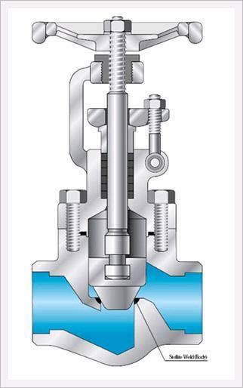

4.2. Pressure profile in a control valve
- Give your comments to the following figure, in particular explain the pressure profile across each of the control valves

F_{L} is the flow recovery coefficient

NB: A well organized and short text will be assessed more than a long and confused one!

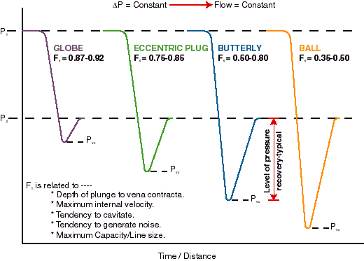

4.3. Sizing Problem
A valve is to be chosen as far as Nominal Size and Intrinsic Characteristic for the following conditions:
fluid: gasoline
density: ρ_{f} = 730 kg/ m³
nominal mass flow rate: $\overset{˙}{m}$ = 2800 lb/min
nominal size of piping to which the valve is to be connected: DN = 2 ½ ”
absolute pressure upstream of the valve in the range: P₁= 14÷12 bar
absolute pressure downtream of the valve: P₂= 8 bar
vapor pressure P_{v} = 0.01x10⁵ Pa
F_{F} = 0.956

- With respect to the above range of variations, calculate the flow coefficient C_{v} for the valve working conditions that appear to be the most demanding

The suggested valves are FISHER series EH and EHA Control Globe Valves. The valve manufacturer data are in the table (see next page).

- Size the valve and choose that one with the most appropriate DN and intrinsic characteristic
- Suggest a possible and reasonable value for the rangeability of the chosen valve.
- Calculate the main points and draw the constant-stroke flow characteristic curve in order to determine whether the valve is operating under cavitation

As a second part of the problem, you’re asked to insert the above valve in a circuit with another process unit that is downstream of the valve and causes a further pressure drop ΔP_{u}:

- ΔP_{u} = ΔP_{n}/2
- ΔP_{u} = 2ΔP_{n}
where ΔP_{n} = P₁ – P₂

- What is the definition of installed characteristic?
- How much is the valve authority V in either case a) or b)?
- in order to have an installed characteristic as close as possible to a straight line, which one of the two valve authority values is the best?

Finally, under the case a. ΔP_{u} = ΔP_{n}/2

- Calculate the volumetric flow rate $\overset{\text{.}}{V}$_{h} that will pass the valve in the circuit if h = 0.55
- Calculate the actual pressure drop across the valve in the circuit if h = 0.55 ?
- What is the value h§ of the relative stroke that determines a flow rate $\overset{\text{.}}{V}$§ = 300 gal(US)/min in the circuit?¶

FISHER EH and EHA Control Valves

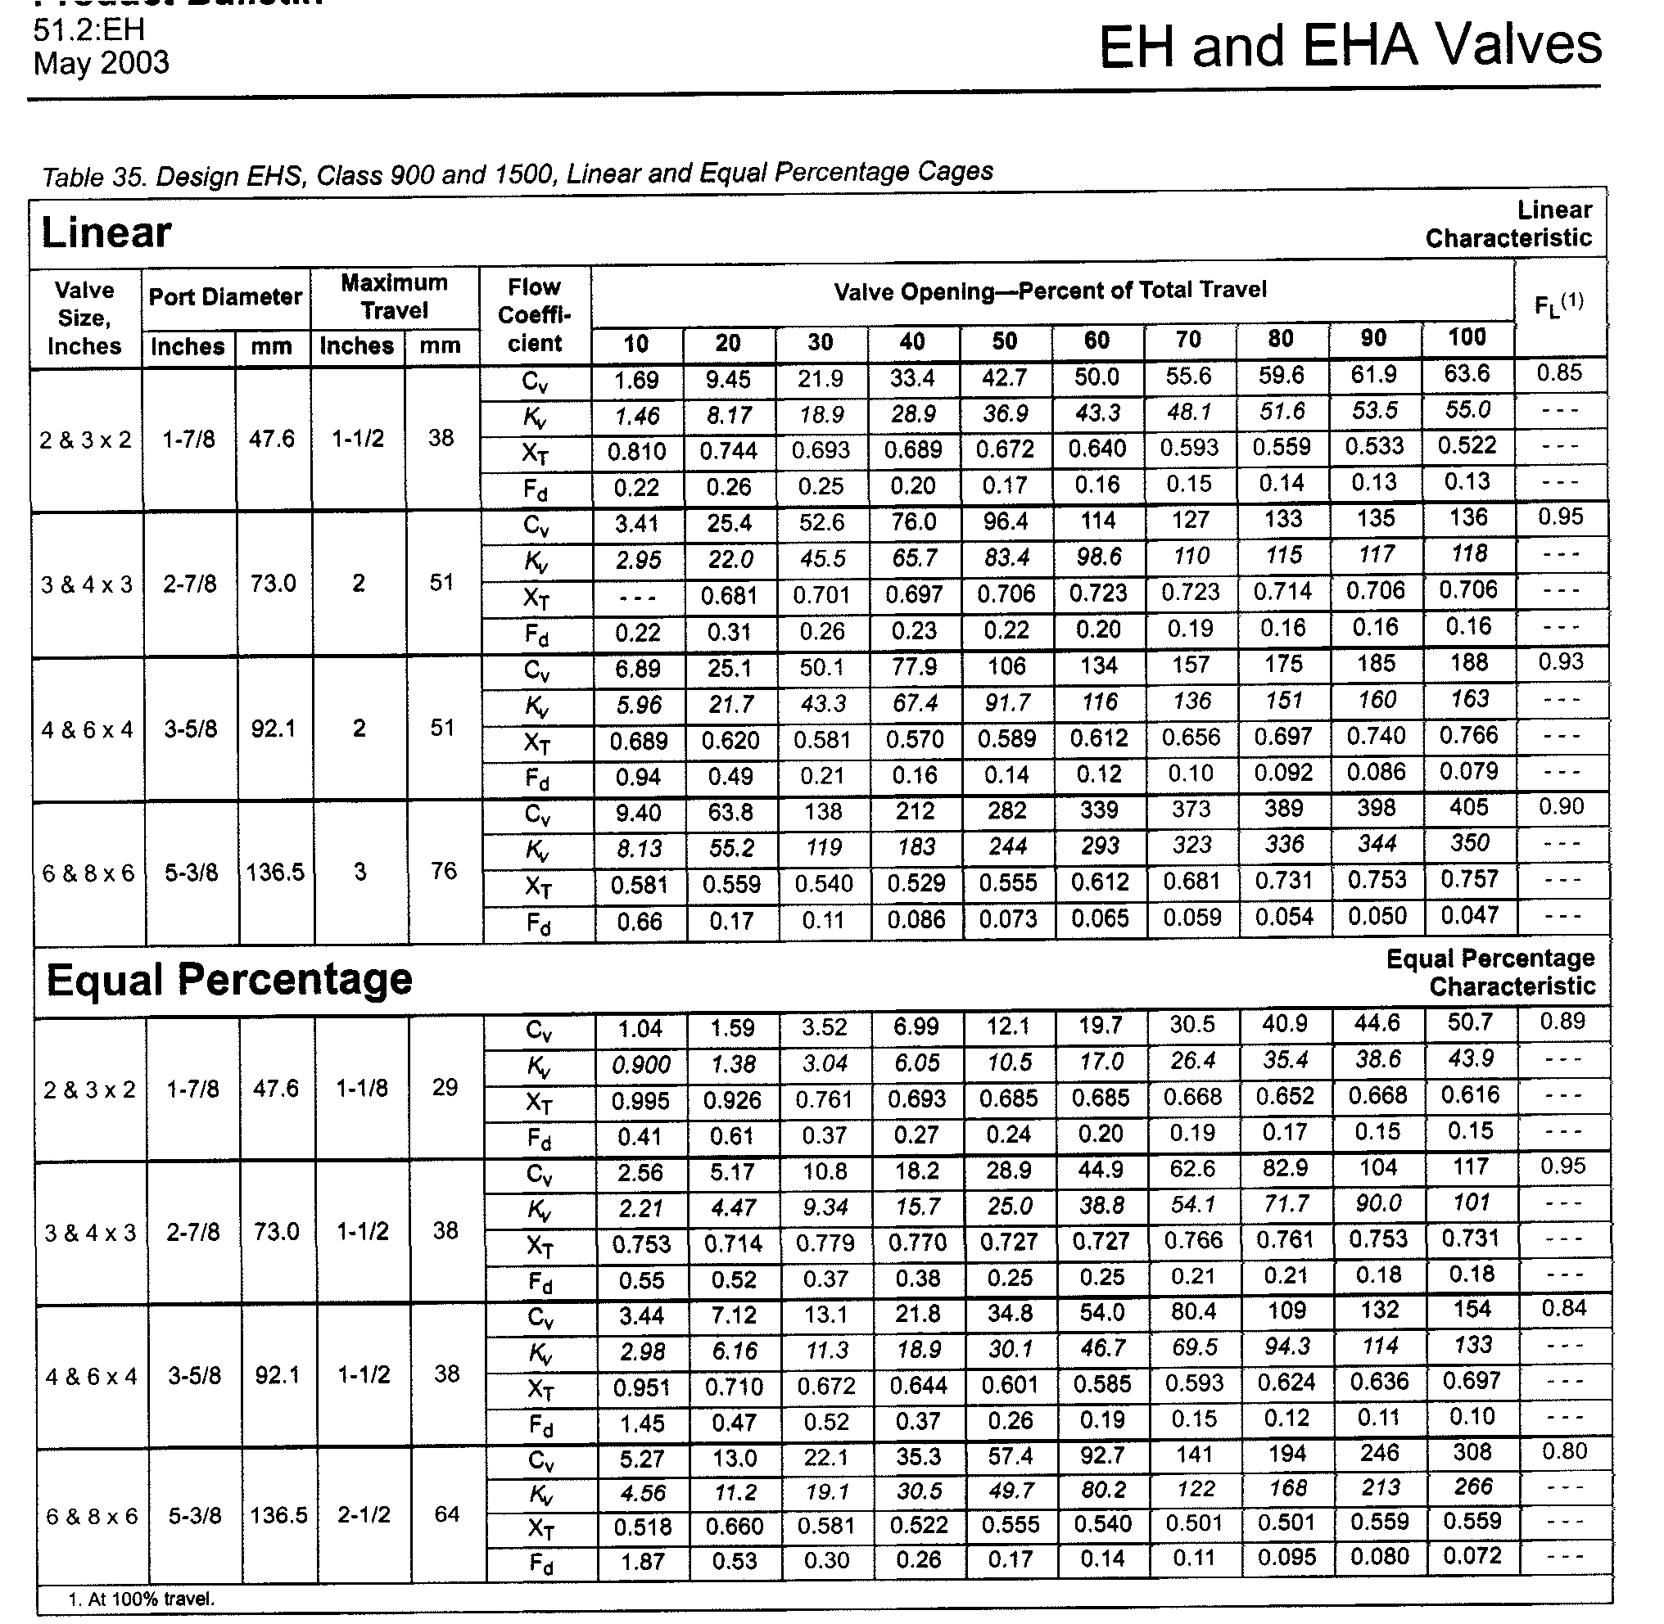

NOTE:
The last digit in each cell of the 1st column “Valve Size, Inches” is the Nominal Diameter.
for instance: 2 & 3 x 2 means DN = 2”

1 a picture that you draw quickly by hand and with few details

