Last name Name matricola

Section 1. TRUE/FALSE QUESTIONS
- The membrane valve got this name just because has a ceramic membrane in contact with the flowing fluid
true o false o
- Closed liquid column manometers (“U” tube manometers) containing mercury are used for measuring pressure in a vacuum
true o false o
- The Coriolis Flowmeter is a transducer of volumetric flowrate
true □ false □
- The sonar level sensors always provide the contemporary measurement of the temperature
true o false o

Section 2. MULTIPLE CHOICE QUESTIONS
- Which one is a dimensionless sensor property?
- □ accuracy at the full scale
- □ accuracy at the measured value
- □ rangeability
- □ sensitivity

- The working principle of a pressure transducer can be:
NOTE: check only the wrong answer!
- □ piezoelectric
- □ radio
- □ inductive
- □ electric resistance

- When the percentage variation of flow through a valve equals the percentage variation of plug movement, a valve has a
- □ Linear flow characteristic
- □ Equal percentage flow characteristic
- □ Quick opening flow characteristic
- □ Parabolic flow characteristic

- Which of the following types of level sensors is not used for liquids?
- □ conductive sensor
- □ vibrating sensor
- □ radar sensor
- □ probe sensor

Section 3: SENSORS AND INSTRUMENTATION FOR PROCESS MEASUREMENTS

3.1 Application of a thermocouple
A N-type thermocouple is used to measure the temperature T_{gc} of a process liquid.
The cold junction of the measuring circuit is at a known temperature: T_{gf} = 293.16 K.
The voltmeter connected to the cold junction provides a measure of the electromotive force that is
V = -0.366 mV

- calculate the temperature of the liquid T_{gc} in ° C, with the approximation of +/- 1 ° C

3.2 The capacitive pressure transducer
- Describe in 3 rows its working principle

3.3 The Level sensors: hydrostatic vs. float
- Describe in 3 rows differences between the working principles

3.4 The general properties of Sensors
- Describe in 3 rows definition and meaning of repeatability

3.5. Contraction-based flow meters
- Derive the flow equation in the ideal case for liquids
- Use the flow equation to calculate the volumetric flow rate of water in the ideal case where P₁=150 kPa, P₂=100 kPa, d₁=90 mm, d₂=20 mm
- Extend the flow equation to the case the flow is not ideal anymore
- Extend the flow equation to fluids with a non-constant density
- Discuss applications, advantages e disadvantages
NB:
A well-organized and short paragraph will be assessed more than a long and confused text!

Section 4: VALVES

4.1. The valve technology and the “Fail–Safe” behavior
- Recognize the type of in the symbol
- What it its application purpose?
- Is it a linear or rotary valve?
- Is it equipped with an external actuator?
- Explain with a short text the action that the valve exerts in the event of a command signal failure

NB: It’s possible to put answers directly on or near the following drawings

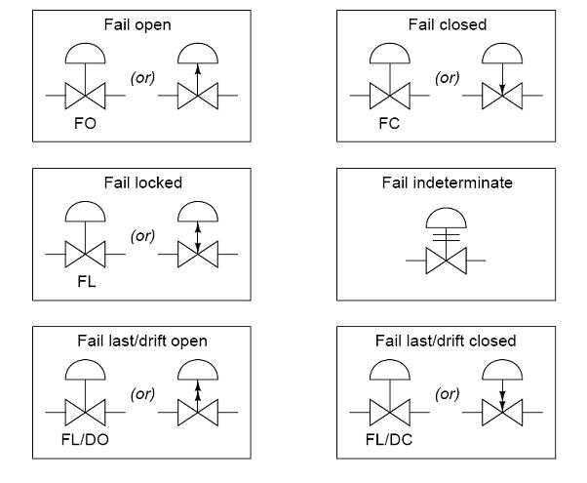

4.2. Sizing Problem
You’re required to size and to choose a valve for the following conditions:
nominal diameter of the line: DN = 150 mm
fluid: sea water, with a density ρ_{f} = 1.025 kg/L
pressure upstream of the valve: P₁ = 2.58 bar
pressure downstream of the valve: P₂ = 1.57 bar
nominal flow rate: $\overset{˙}{m}$ = 90 kg/s
vapor pressure: P_{v} = 4000 Pa
liquid critical pressure ratio factor: F_{F} = 0.956

1. Calculate the flow coefficient C_{v} for the above conditions

You have a SUN WP "2 piece" full-bore ball valve,
with the following manufacturer’s table of C_{v} (US gal min⁻¹ psi^{-½}) as a function of the opening angle θ (as reported in a row for each DN):

DN (mm) | C_{v} (gpm psi^{-1/2}) as a function of the opening angle θ
 | 20° | 30° | 40° | 50° | 60° | 70° | 80° | 90°
40 | 3 | 8 | 10 | 15 | 27 | 58 | 96 | 165
50 | 5 | 9 | 15 | 23 | 41 | 86 | 140 | 245
65 | 11 | 18 | 27 | 39 | 71 | 150 | 245 | 410
80 | 18 | 28 | 44 | 65 | 115 | 245 | 400 | 685
100 | 26 | 55 | 85 | 130 | 230 | 480 | 785 | 1.275e3
125 | 45 | 72 | 110 | 165 | 300 | 610 | 1.01e3 | 1.715e3
150 | 70 | 110 | 168 | 250 | 465 | 980 | 1.615e3 | 2.67e3
200 | 80 | 135 | 210 | 310 | 540 | 1100 | 1.91e3 | 3.185e3

2. Choose the best suitable DN for the valve
3. Plot the intrinsic characteristic of the chosen valve in a diagram
4. Which type is the intrinsic characteristic?

Next, you are requested to insert the chosen valve in a circuit, assuming ΔP_{n} equal to the original value (P₁ - P₂) and considering the following three cases for the user pressure drop:
- P₂ – P₃ = ΔP_{u} = ΔP_{n}
- ΔP_{u} = ΔP_{n}/2
- ΔP_{u} = 2ΔP_{n}

5. How much is the authority V in the 3 cases?

Furthermore, under the condition ΔP_{u} = 2ΔP_{n}

- How much is the volumetric flowrate $\overset{\text{.}}{V}$_{θ} passing through the valve for θ = 40 °?
- How much is the pressure drop ΔP_{v,θ} through the valve for θ = 40 °?

It is requested to take into account the use of the same valve in the case the pressure upstream of the valve P₁ increases by 30% compared to the initial value and the nominal flow rate increases by 50% compared to the initial value:

- For such new flow conditions, is the valve selected in step 2 still suitable? Why?
- For such new flow conditions, does any cavitation occur?

