## 4.3. Sizing Problem

A valve is to be chosen as far as **Nominal Size** and **Intrinsic Characteristic** for the following conditions:

fluid: gasoline

density: ρf = 730 kg/ m3

nominal mass flow rate:  = 2800 lb/min

nominal size of piping to which the valve is to be connected: DN = 2 ½ ”

absolute pressure upstream of the valve in the *range*: P1= 14÷12 bar

absolute pressure downstream of the valve: P2= 8 bar

vapor pressure Pv= 0.01x105 Pa

FF = 0.956

1. With respect to the above range of variations, calculate the **flow coefficient Cv** for the valve working conditions that appear to be the most demanding

The suggested valves are FISHER series *EH and EHA Control Globe Valves*. The valve manufacturer data are in the table (see next page).

1. **Size the valve** and choose that one with the most appropriate DN and intrinsic characteristic
2. Suggest a possible and reasonable value for the *rangeability* of the chosen valve.
3. Calculate the main points and draw the **constant-stroke flow characteristic curve** inorder to determine whether the valve is operating under **cavitation**

As a second part of the problem, you’re asked to insert the above valve in a circuit with another process unit that is downstream of the valve and causes a further pressure drop Pu:

1. Pu = Pn/2
2. Pu = 2Pn

where Pn = P1 – P2

1. What is the definition of **installed** **characteristic**?
2. How much is the **valve** **authority** V in either case a) or b)?
3. inorder to have an **installed** **characteristic** as close as possible to a straight line, which one of the two **valve** **authority** values is the best?

Finally, under the case a.  Pu = Pn/2

1. Calculate the volumetric flow rate h that will pass the valve in the circuit if h = 0.55
2. Calculate the actual pressure drop across the valve in the circuit if h = 0.55 ?
3. What is the value h§ of the relative stroke that determines a flow rate § = 300 gal(US)/min in the circuit?¶

FISHER EH and EHA Control Valves

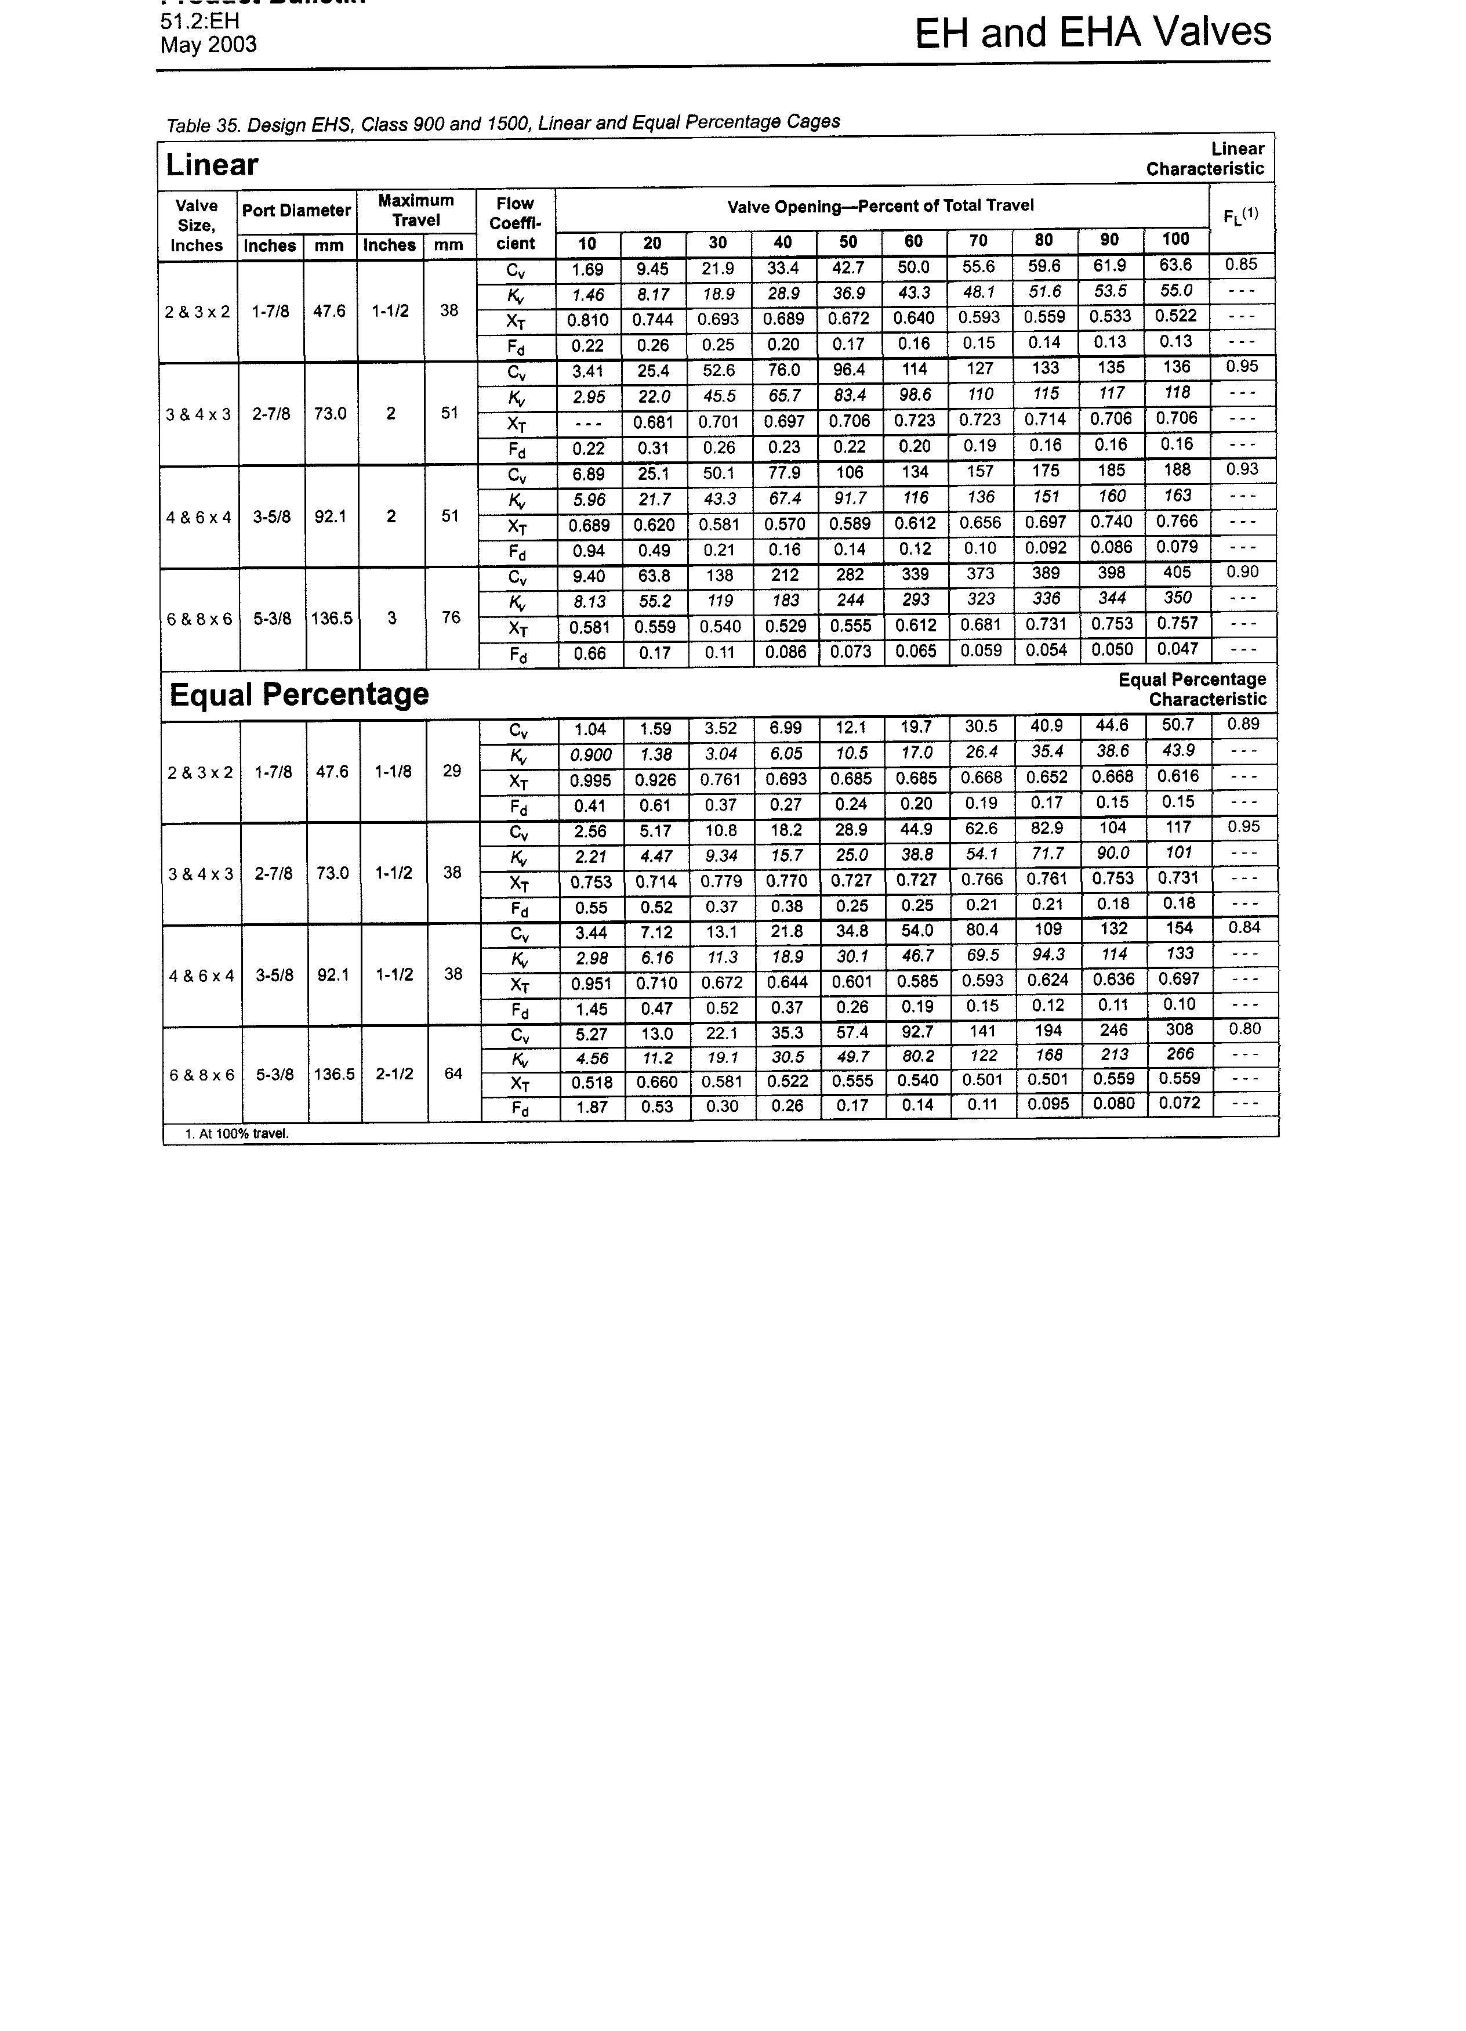

NOTE:

The last digit in each cell of the 1st column “*Valve Size, Inches*” is the **Nominal Diameter**.

for instance: 2 & 3 x 2 means DN = 2”