## Surname Name Student’s code.:

## NO scientific calculator allowed!

# Section 1: QUIZ

1. The damping factor of a system of 2nd order can also be negative

true 🞏 false 🞏

1. A dynamic system of the 3rd order always consists of 3 systems of 1st order in series

true 🞏 false 🞏

1. The formulas calibration IAE minimize the integral module of the error

true 🞏 false 🞏

# Section 2: QUIZ

1. An industrial controller can be:

NB: mark only the wrong answer !

a. 🞏 "direct action"

b. 🞏 "reverse action"

c. 🞏 relay

d. 🞏 FOPDT

1. The offset is:

a. 🞏 y∞ – ySP(t)

b. 🞏 ySP(t) – y∞

c. 🞏 y∞ – ym(t)

d. 🞏 always positive

# Section 3: REFERENCE DYNAMIC MODELS

## 3.1. Dynamic response of 2nd order

h1(t)

h2(t)







A1

A2

The system formed by the two tanks in the figure operates under steady conditions with an input flow rate of 1 m3 / min and with the following additional data:

A1= 2 m2 A2= 1 m2 R1= 1.5 m/(m3/min) R2=3 m/(m3/min)

1. What is the time constant of each tank?

2. What is the static gain of each tank?

At time t = 0 the flow into the first tank is raised sharply to 1.5 m3 / min. You want to know as a result of this disorder:

1. what will be the total variation in height of the 1st tank for long time
2. how long it takes the level change of 1st tank to reach 95% of final value.
3. what will be the total variation in height of the 2nd tank for long time
4. how long it takes the 2nd tank to reach 70% of the total variation

**NB:** **to answer these questions, you are asked to make use of generalized diagrams of the dynamic response following attachments.**

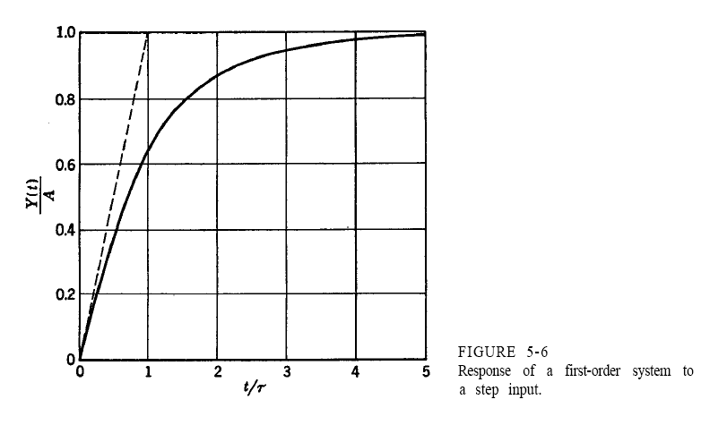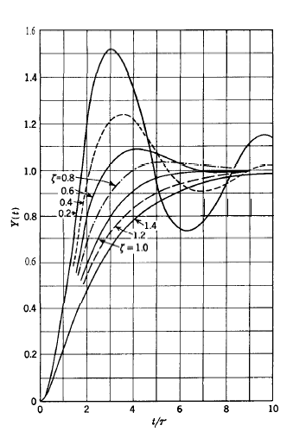

## 3.2. Poles and zeros of a transfer function

1. Calculate the poles of the following FdT



1. calculate the zeros of FdT
2. draw the complex plane, and places each of the poles on it
3. for each of the poles, provide the contribution it gives to the dynamic response in the time domain

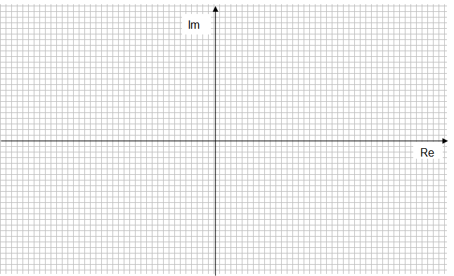

# Section 4: CONTROL AND MONITORING

## 4.1. The feedback control

The figure shows a practical application of feedback control.

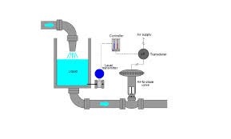

Among the various variables (flow rate, etc.)

1. select the **controlled variable**
2. select the **manipulated variable**
3. select the **disturbance variable** (if any)

Draw the specific Feedback Block Diagram for this case and be careful to have in it:

1. All the control **block component** blocks that are specific to the case in question
2. All the control **loop variables** that are specific to the case in question

# Section 5: CONTROLLERS

## 5.1 Tuning the PID controller

* 1. Discuss the issue of tuning a PID controller .

NOTE: Try to be concise and clear in text !

# Section 6: MATHEMATICAL MODELLING

A cylindrical tank (radius R and height hc) is used (see. Figure) for the storage and distribution of the washing waters of tomatoes in a food industry.

The washing water enters from the top with a volumetric flow  and leaves simultaneously by 3 different exit ports indicated in Fig.

Use the following assumptions:



1. The free surface of the liquid can be considered always horizontal.

2. The system is isothermal

3. ρ = const.

4. The flow rate  has linear dependence from the liquid head at the port

5. The flow rate  has linear dependence from the liquid head at the port

6. The flow rate is that taken by a centrifugal pump operating at constant rpm and power in time

The variable that is to be predicted with the model is the liquid level h(t) in the tank.

Therefore, you’re asked to:

a. write the mathematical model in stationary  
b. write the dynamic mathematical model in the time domain  
c. classify the dynamic mathematical model thus obtained  
d. identify input variables, state and output, as well as the parameters of the model  
e. discuss which of the input variables can be taken as forcing functions and what kind of reasonably, given the nature of the problem  
f. express the model in deviation variables  
g. take the dynamic model in the Laplace domain  
h. determine the transfer function