## Surname COGNOME Name Nome Student code matricola

## There is no need, Actually, it is NOT allowed using the calculator to make this test

# Section 1: QUIZ

1. The time parameter τ of a **2nd order transfer function** coincides with the time required for the step response to reach 50% of the final value

True  false

1. The damping factor of a 2nd order system can also be negative

True  false

# Section 2: QUIZ

1. A controller can be:

Pls. check the wrong answer!

a.  "direct action"

b.  "reverse action"

c.  relay

d.  FOPDT

1. The PI controller transfer function is

a.  Gc=Kc[1+ Is]

b.  Gc=Kc[1+1/(Is)]

c.  Gc=Kc[1/(1+Is)]

d.  Gc=Kc/(Is)

1. Which of the following "parameters" is not included in the 2nd order system law?

a.  Process gain

b.  *overshoot*

c.  Natural oscillation period

d.  Damping factor

1. The offset is:

a.  y – ySP(t)

b.  ySP(t) – y

c.  y – ym(t)

d.  Always positive

# Section 3: DYNAMIC REFERENCE MODELS

## 3.1. Properties of the 1st order dynamic response

A first-order dynamic system, with unknown **parameters**, is disturbed by

i. a **step input with amplitude** **3.5** and

ii. a **unit impulse input**.

The dynamic response in both cases is y(t)=8 at the dimensionless time t/τ=1.5.

By using the **generalized diagrams** attached here, please calculate:

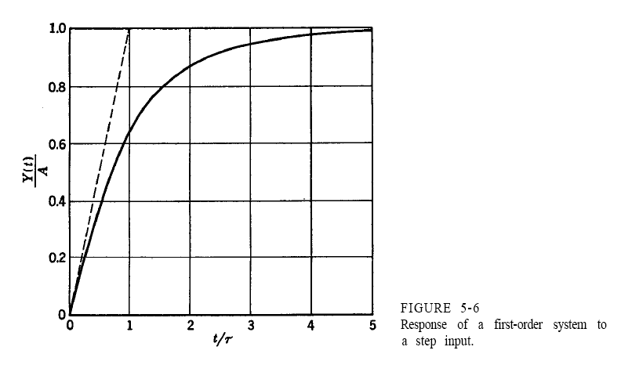

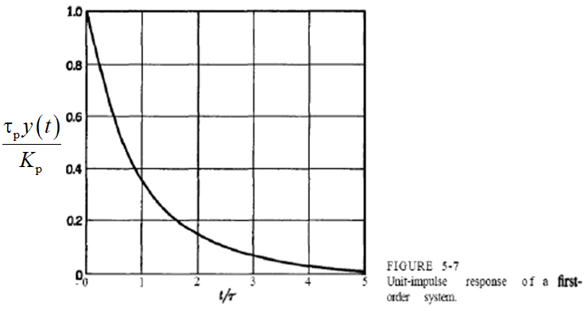

1. static gain

Type your answer here! There is no text limitation

1. time constant

Type your answer here! There is no text limitation

1. the value y(0) of the dynamic response to unit impulse input at the origin (t/τ=0)

Type your answer here! There is no text limitation

## 3.2. Parametric model

The dynamics of a process is described by the following **transfer function**:



where k is a **parameter**.

1. What **order** is this dynamic system?

1. How much is the **static gain *K*p** parametrically expressed as afunction of k ?

Type your answer here! There is no text limitation

1. How much is the **time constant** in the denominator?

Type your answer here! There is no text limitation

1. Assign a suitable value to the **parameter** k so that the numerator has a **zero** equal to a **pole**

Type your answer here! There is no text limitation

## 3.3. Poles and zeros of a transfer function

Not all **transfer function** have **poles**!

1. How is a **transfer function** called if it contains **poles** and **zeros** only?

Type your answer here! There is no text limitation

For the following TF



1. calculate the **poles**
$p_{1}=\frac{}{}+j\sqrt{\frac{}{}}; p_{2}=\frac{}{}+j\sqrt{\frac{}{}}; p_{3}=\frac{}{}+j\sqrt{\frac{}{}}; p_{4}=\frac{}{}+j\sqrt{\frac{}{};}$

2. 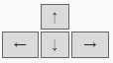place each of the **poles** on the **complex plane** (select the pole in the graph and move it with the arrow keys)



**p2**

**X**

**p1**

**X**

**p4**

**X**

**p3**

**X**

1. consider each **pole** or pair of **poles**, separately; for each **pole** or pair of **poles**, provide the type of stability that characterizes its **dynamic response** in the time domain

**p1** Type your answer here! There is no text limitation

**p2** Type your answer here! There is no text limitation

**p3** Type your answer here! There is no text limitation

**p4** Type your answer here! There is no text limitation

# Section 4: PROCESS CONTROL

## 4.1. *Feedback* control

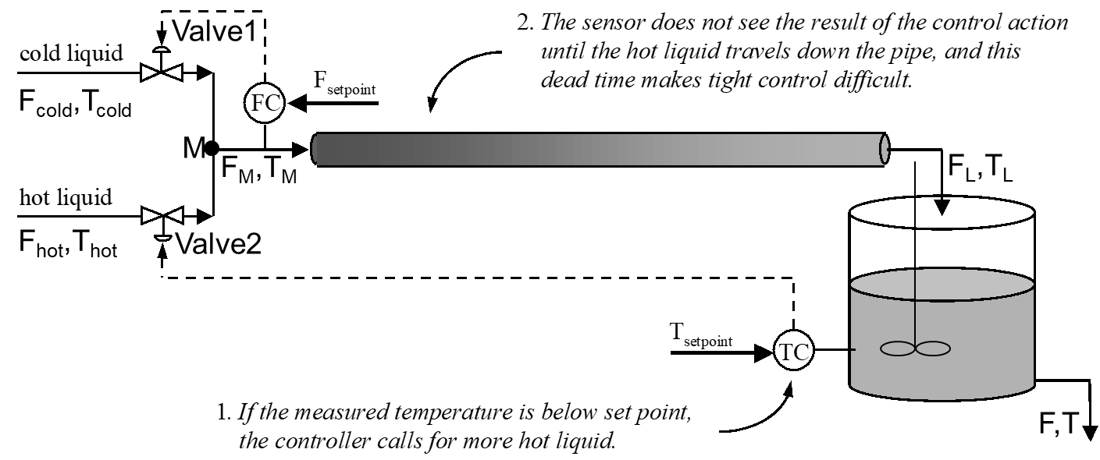The figure shows a **simplified PI&D** of a continuous process with ***feedback* control**.

With ref. to the control loop dedicated to **temperature in the mixer**, among the various variables (flow rate, temperature, etc.), please

1. select the **controlled variable**

1. select the **manipulated variable**
2. select the **disturbance variable** (if any)
3. Define the role that each control **block component** has in the Feedback Block Diagram, and that is specific to the case in question

liquid tank

mixer

control Valve1

control Valve2

FC

TC

1. What kind of **signals** is used for communication in this case of ***feedback* control**?

Type your answer here! There is no text limitation

# Section 5: CONTROLLERS

## 5.1 PID controller *tuning*

A **PID** controller is subjected to a first *tuning* procedure (*Approximate Model tuning*) and the dynamic system controlled by it at closed loop is subjected to a *step* response in the *set point* (see the **dynamic response** with a continuous curve in fig.).

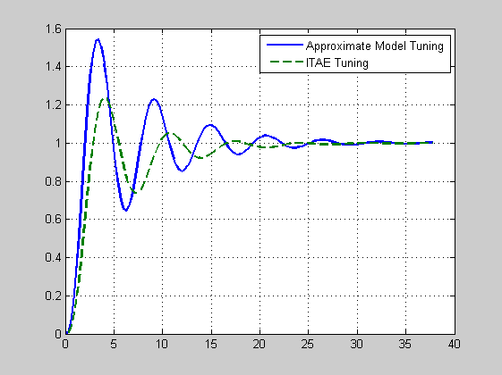

Then, the same **PID** controller is subjected to an ITAE *tuning* procedure and the dynamic system controlled by it at closed loop is again subjected to a *step* response in the *set point* (see the **dynamic response** with dashed curve in fig.).

1. What is the ITAE formula?

$\int_{0}^{∞}{e^{2}dt}$ $\int_{0}^{∞}{\left|e\right|dt}$ $\int_{0}^{∞}{te^{2}dt}$ $\int_{0}^{∞}{t\left|e\right|dt}$

 

1. Which one of the 2 **dynamic responses** is better?

Type your answer here! There is no text limitation

1. Discuss (qualitatively) the characteristics of **dynamic response** with ITAE *tuning*.

Type your answer here! There is no text limitation

# Section 6: MATHEMATICAL MODELS

## 6.1. Development of a dynamic mathematical model for a lumped parameter system

TO BE SOLVED BY PEN AND PAPER AND TO BE SENT AS A SEPARATE FILE

(DA SVOLGERE CON CARTA E PENNA E DA INVIARARE SEPARATAMENTE COME FILE)

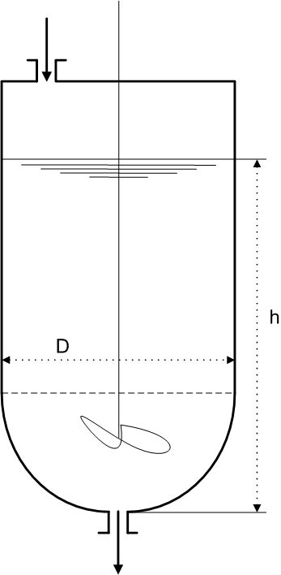In a dairy plant handling milk whey, from the top of a cylindrical tank (see figure) a volumetric flow rate iis introduced at a temperature Ti(t) and a volumetric outflow rate ois taken from a emisphere-shaped bottom (having the same diameter D of the cylinder) at a temperature T(t).

The following **hypotheses** hold:

1. Perfect mixing in the tank.
2. ρ = constant.
3. cp = constant.
4. i = constant.
5. constant volume of the liquid.
6. isothermal tank.
7. perfectly insulated tank.

The variable to be predicted with the math model is the temperature T(t), after taking care to express in detail the overall volume V of the liquid.

You must:

1. write a **steady state** model
2. write a **dynamical** model
3. reduce the **dynamical** model, if possible, to the **canonical form** in the time domain
4. classify theobtained **dynamical** mathematical **model**
5. list **input, state, output variables** and the **parameters** of the model
6. discuss which input variables can be assumed as **forcing functions** and which are their possible functional forms for the physical feasibility
7. re-write the model using the **deviation variables**
8. take the model into the Laplace domain
9. determine the **transfer function**