Last name Name matricola

Section 1: TRUE/FALSE QUIZ
- A command air pressure of 3-15 psi is typical of membrane actuators
true o false o
- The response time is the time interval which elapses before the step response reaches a value that differs no more than 6 % from its final steady-state value
true o false o
- A relay controller can operate without hysteresis
true o false o
- The zero of a rational transfer function is a value of s for which the denominator vanishes
true □ false □

Section 2. MULTIPLE CHOICE QUESTIONS
- Which of the following ones is not an actuator?
- □ hydraulic ram
- □ centrifugal pump
- □ relay controller
- □ heating or cooling element

- The Laplace transform cannot be used to solve
a. □ second order differential equations
b. □ linear or linearised differential equations
c. □ nonlinear differential equations
d. □ higher-order linear differential equations

- Which of the following acronyms does not correspond to a fitting model for the response of a system with an unknown dynamics?
a. □ SOPDT overdamped
b. □ SO with Lead Time
c. □ SOPDT underdamped
d. □ FOPDT underdamped

- The offset is:
a. □ y∞ – y_{SP}(t)
b. □ y_{SP}(t) – y∞
c. □ y∞ – y_{m}(t)
d. □ always positive

Section 3: REFERENCE DYNAMIC MODELS
The system formed by the two tanks in the figure operates in steady state conditions with an inlet flow $\overset{\text{.}}{V}$_{0s} equal to 9.4 m³/min and with the following additional data:
A₁= 30 m² A₂= 50 m² R₁= 1.2 m/(m³/min) R₂=0.7 m/(m³/min)

1. What is the time constant of each tank?

At time t = 0 the flow $\overset{\text{.}}{V}$₀ (t) entering the first tank is sharply raised from the $\overset{\text{.}}{V}$_{0s} value to a new value of 10 m³/min.
You want to know as a result of this disturb:

2. what will be the total variation in height of the 1st tank for long times
3. how long is the time for the variation in the level of the 1st tank to reach 90% of final value.
4. what will be the total variation in height of the 2nd tank for long times
5. how long is the time for the 2nd tank to reach 50% of the total variation

NB: For these questions, it is suggested to consult generalized diagrams of the dynamic response hereby attached.

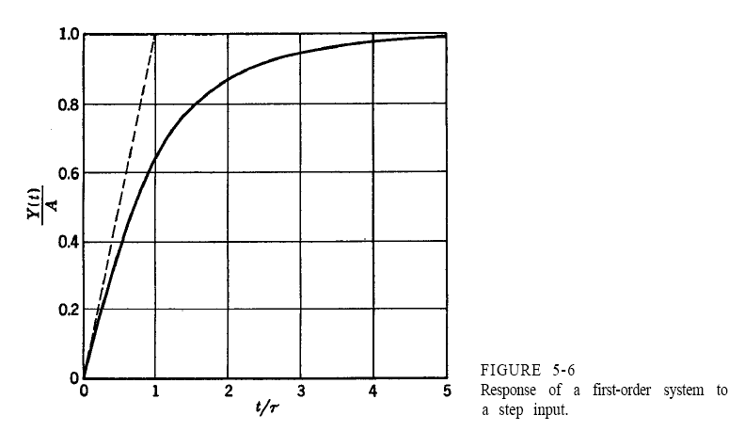
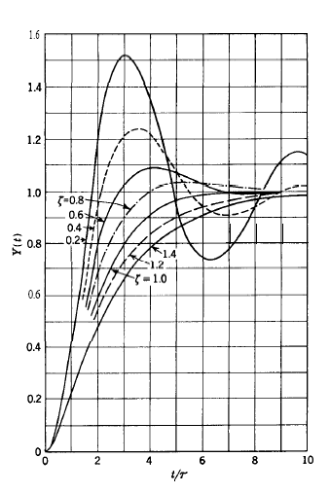

Section 4: PROCESS REGULATION AND CONTROL

4.1. Feedback control
- Draw the Block Diagram for the most general case representing the feedback Control problem.
- Describe briefly the variables appearing one by one in the feedback control loop

NOTE: A well organized and short text will be assessed more than a long and confused text!

Section 5: CONTROLLERS

PID controller tuning
The following diagrams report the dynamical response (see the upper curve) to a step input (see the lower curve) for three processes whose dynamics is unknown. It is required to tune a PID control for each of them.

NB:
only qualitative answers are required: numerical computation need not be performed!

- Which dynamical model do you reckon must be adopted for a process, given the diagram of its step test response in the following figure?
- List the parameters involved in this model
- Which tuning rules do you believe can be used in this case?

- Which approximating dynamical model must be adopted for the process whose dynamical response to step test is given in the following figure?
- List the parameters involved in this model
- Which tuning rules do you believe can be used in this case?

- Which method has been used to generate this dynamical response (see output curve) to a step change in the set point?
- List the parameters involved in this method
- Which tuning rules do you believe can be used in this case?

Section 6: MATHEMATICAL MODELING
6.1 Development of a mathematical model for a lumped-parameter system
A tank for storage of waste water in food industry is specially shaped (see the side figure): it is composed of a sphere of radius r overlapped to a cylinder of radius r₁ and height h_{c}.
A volumetric liquid flow rate ${\overset{˙}{V}}_{i}\left(t\right)$ is introduced from the top while a stream goes out near the bottom from an outlet port at the height h₀.
The liquid level in the tank h(t) is the variable that we want to predict with the model, after expressing in detail the volume V(t) of the liquid as a function of the level h(t).

The following hypotheses hold:

- The liquid upper surface can be considered horizontal
- The system is isothermal.
- The fluid density ρ is constant;
- The volumetric outlet flow rate ${\overset{˙}{V}}_{o}$ is linearly related to the hydrostatic pressure of the liquid level

With ref. to the further hypothesis:
- The liquid level is lower than the cylinder height: h(t) < h_{c}

You must:
- write a steady state model
- write a dynamical model
- if possible write the dynamical model in the canonical form in the time domain
- classify the obtained dynamical model
- list input, state, output variables and the parameters of the model
- discuss which input variables can be assumed as forcing functions and which are their possible functional forms for this physical problem
- write the dynamical model in terms of deviate variables
- transport the dynamical model into the Laplace domain
- obtain the transfer function

Later, the hypothesis 5 changes as follows:
5’ The liquid level is higher than the cylinder height: h(t) > h_{c}
You’re asked:

- What are the main changes in the new dynamical model for this case?

