Last Name ___________ Name___________ matricola _________
PC No. ___________

Section 1: LINEAR PROGRAMMING
Objective function
z = 2x - 7y max!
Constraints
x > 2
1/3 x + y < 10
-1/3 x + y < 6
10x + y < 97(100-n)/(100+n)
-x + y > -8
Non-negativity constraints
x , y ≥ 0
where n = PC number
Questions
- Use the Graphical Method, explain it briefly, attach the graph and find the max! (optimal value of the objective function and optimal values of the decision variables)
- Use the Simplex algorithm, attach the various tableaus and, again, find the max! (optimal value of the objective function and optimal values of the decision variables)
- How many variables and of which type should be added to the decision variables?
- On the basis of the Simplex theory, briefly comment the procedure used in Matlab®
- What happens if the objective function becomes: (z = 2 x - 6 y) ?

Section 2: EMPIRICAL MODELS

= = =

Section 3: FINITE DIFFERENCE METHODS for PDE
Solve the following parabolic PDE 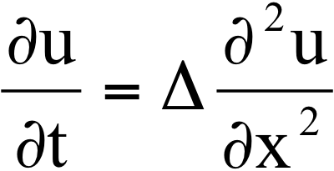
with
Δ = n
L = 1
t_{final} = 5
IC: t = 0 u(x,0) = sin(x)
BC: $A⋅u\left(x,t\right)|_{x=0}+B\frac{∂u\left(x,t\right)}{∂x}|_{x=0}$ =x/n
$D⋅u\left(x,t\right)|_{x=L}+E\frac{∂u\left(x,t\right)}{∂x}|_{x=L}=\sqrt[n]{x}$
A=B=C=D=n
where n = PC number:

- which type are the Boundary Conditions?
- adopt the explicit method and, using MUC, explain the procedure briefly, attach the graph and comment the final solution
- discuss the stability of the used method

