## Last name: ANBALAGAN Name: MOHAN MALKANI student ID No.: 0622800231

**PC No. 33**

# Section 4: STABILITY OF LINEAR DYNAMIC SYSTEMS

A dynamic process G has the following transfer function

$$G_{}=\frac{s+n}{s^{2}\left(s+\frac{n}{2}\right)}$$

where **n = PC No. 33**

1. Is Gp(s) a **minimum phase system**?

**Yes, it is a minimum phase system because it doesn’t have any dead time, it doesn’t have any negative gain value, all poles are on the left half of plane, and the zero is on the left half of the plane.**

1. How much is the **gain**?

**Kp=dcgain(G)**

**Kp =**

**Inf**

**Gain(Kp)=Inf**

## Part A: *Root locus*

For the **system** G(s), plot the *root locus* by means of Matlab and SisoTool resources, attach it and answer here the following questions:

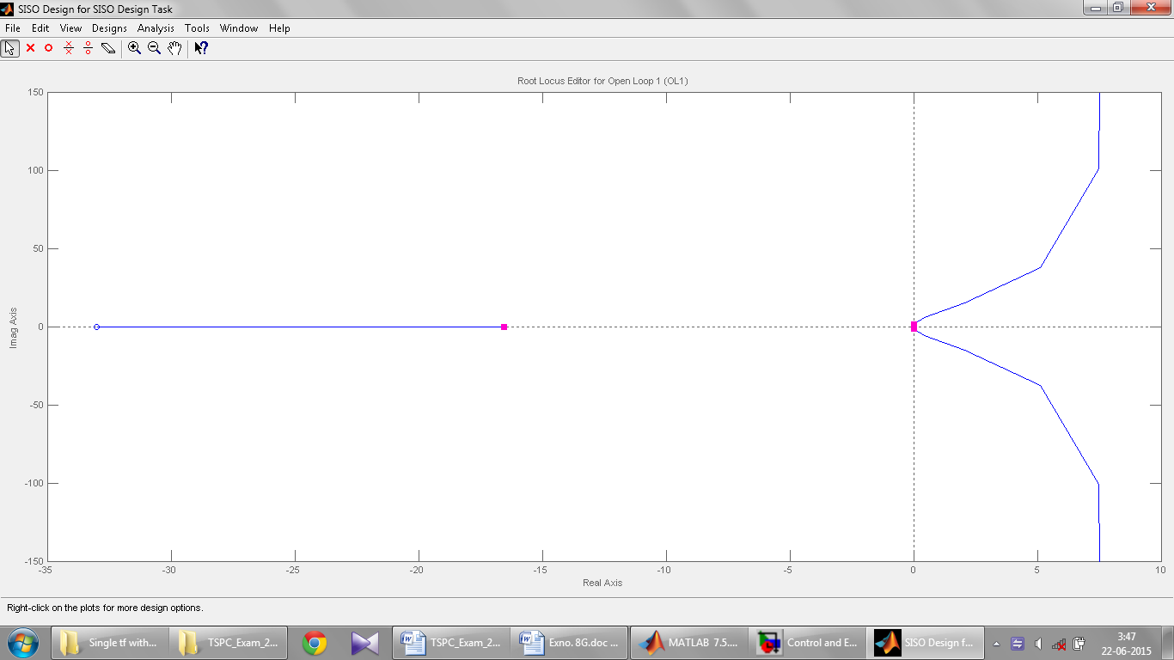

1. Determine poles, zeroes and No. of trajectories.

**p=pole(G)**

**p =**

**0**

**0**

**-16.5000**

**>> z=zero(G)**

**z =**

**-33**

* **The first rule of Evans says that the number of paths is equal to the number of poles of the transfer function in open loop, in this case, and then we have trajectories 3**

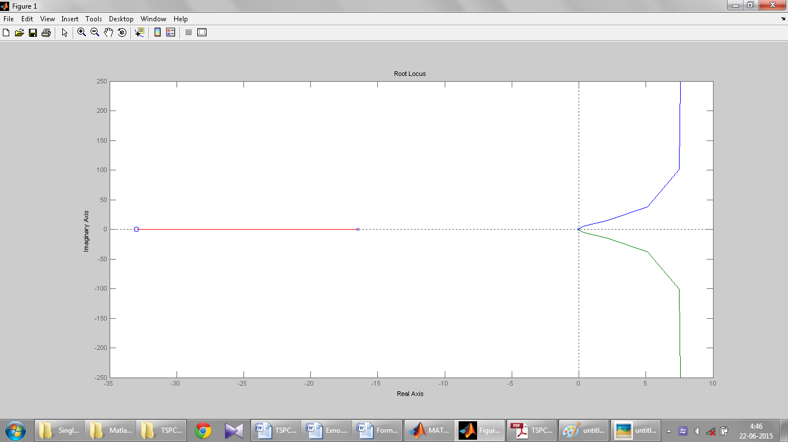

1. Discuss existence of asymptotes and, if possible, calculate the gravity center and angles formed with the real axis.

**There are n-m asymptotes (where n = order of the denominator of the transfer function; m = order of the numerator of the transfer function) for which the trajectories, having no zeroes corresponding on which end, there tend asymptotically tend to K of infinity**

**Angle**

**Intersection point( intercept ) calculated by :**

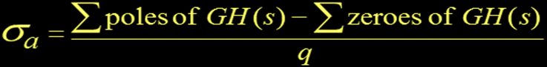

**In this case we have n-m = 3-1 = 2 asymptotes whose center of gravity is given by:**

**range = (Σpi-Σzj) / n-m**

**sigma=(sum(p)-sum(z))/(n-m)**

**sigma =**

**8.25**

**The angle formed by these asymptotes with respect to the real axis is given by:**

**Theta = (2k +1) π / (n-m) with k = 0,1,2 ... n-m-1**

**=π/2, 3 π/2**

**Center of gravity is 8.25**

**Angles formed with the real axis is π/2, 3 π/2**

1. Calculate the limiting value/values for Kc.

**There is no limiting value for Kc.**

**The system is unstable for all the values of Kc**

## Part B: Frequency response

For the **dynamic system** Gp(s) and a **P controller** with Kc=1:

1. Plot the**Bode Diagrams**by means of Matlab resources, with a log scale of the magnitude (NOT in dB), and attach them here

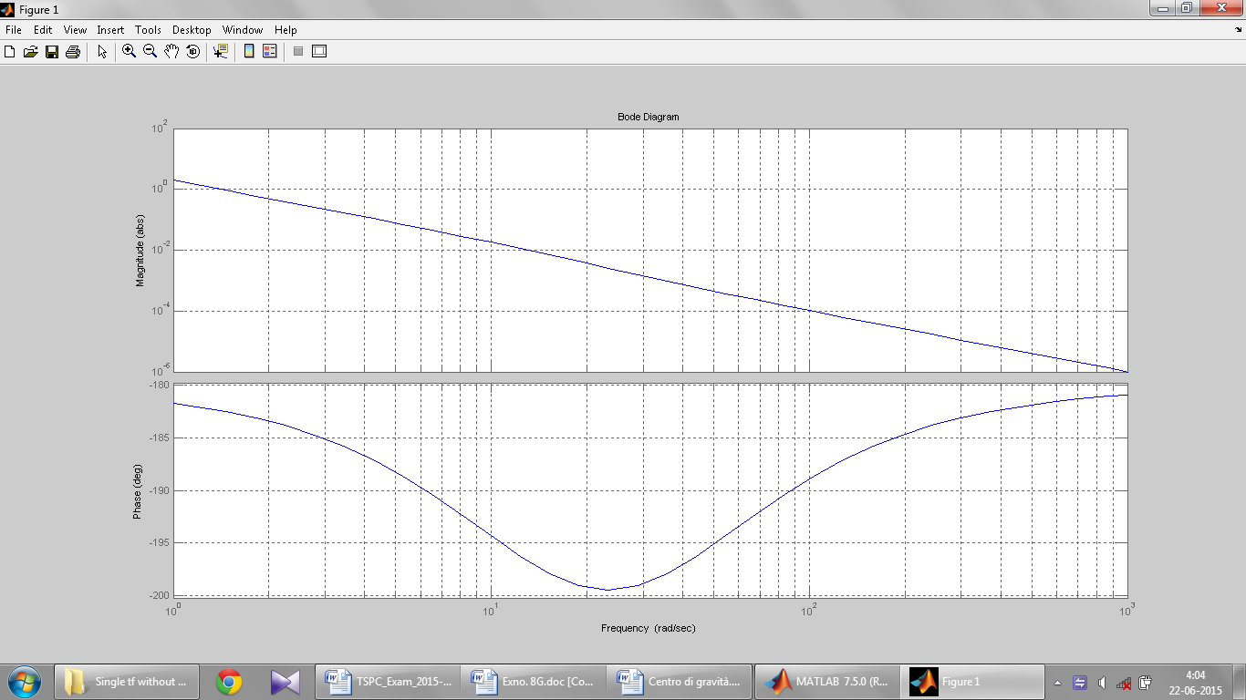

1. Does a **resonance** frequency exist? How much is it?

**The resonance frequency is the value of the frequency at which the peak occurs at resonance.**

**The resonance peak is the maximum value taken from the diagram of the amplitudes.**

**But in our case we don’t have any resonance frequency.**

1. Does a *crossover* frequency exist? How much is it?

**The crossover frequency is the particular value of the pulse which corresponds to a phase delay equal to -180 °**

**Yes, there exist a crossover frequency and the value is 0 rad/sec,**

**which can be seen from the Bode diagram,**

**as well as from the following command:**

[mag,phase] = bode(G,[eps])

*% returns* AR *and* phase shift *as* lowfrequency (*asymptotic)* *values*

mag =

4.0565e+031

phase =

180

1. Does a *gain* *crossover* frequency exist? How much is it?

**The crossing frequency gain (or gain crossover) is the value of that particular pulse which corresponds to a module AR unity/one.**

**Yes, there exist a gain crossover frequency and the value is 1.41 rad/sec, which can be seen from the bode diagram.**

1. Check, on the base of the Bode stability criterion, if the above system is closed-loop stable

**Bode stability criterion**: **a feedback control system is BIBO unstable if AR FdT of the open loop is greater than 1 at the crossover frequency.**

**If there is no crossover frequency, the system is always stable.**

**The criterion does not apply when:**

**- The gain is negative**

**- The transfer function has poles positive real part**

**- The transfer function has zeroes positive real part**

**- The phase diagram (phi) shows more of a crossover frequency at phi = -180 °**

**- The diagram of AR show more crossover at AR = 1**

**Under this criterion, the closed-loop system is unstable.**

1. Plot the**extended Nyquist diagram** togetherwith the unit circleby means of Matlab resources and attach it here

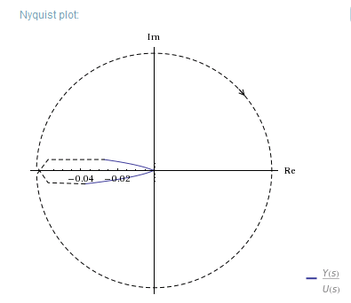

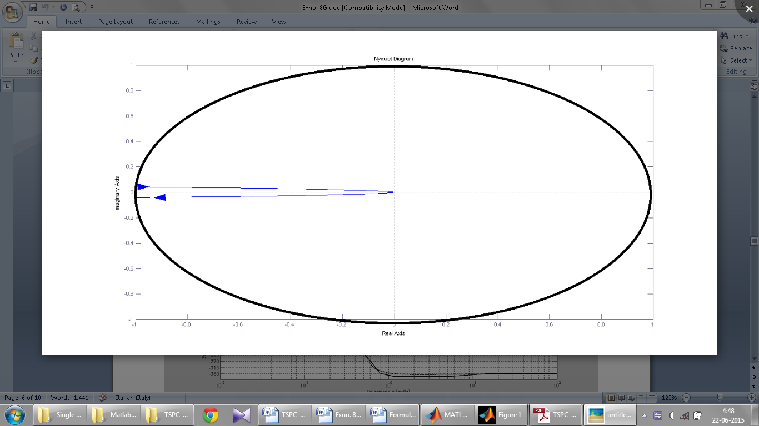 The extended Nyquist diagram missing the closure at infinity The correct Nyquist diagram

1. Check, on the base of the **Nyquist** stability criterion, if the above system is closed-loop stable

**On the basis of the Nyquist stability the feedback system is asymptotically stable if and only if the complete diagram of Nyquist accomplishes around the critical point -1 many turns counterclockwise how many are the poles positive real part and many half turns in the sense counterclockwise (even without surround the point -1) as the number of pure imaginary poles.**

**If the FdT open loop intersects the point (-1, 0) on the Nyquist diagram, there is a ~~boundary~~ condition of stability as AR = 1 and ϕ = -180 °.**

**Unlike the Bode stability criterion, the Nyquist criterion can also be applied to systems unstable in open loop.**

**If we draw the unit circle in the nyquist plot, under this criterion, the closed-loop system is unstable because the critical point (-1,0) is circled once.**

## Part C: Dynamic responses in the time domain

For the **dynamic system** Gp(s), by means of Matlab resources:

1. plot the **open-loop** dynamic response to a unit step, attach it here and give your comments

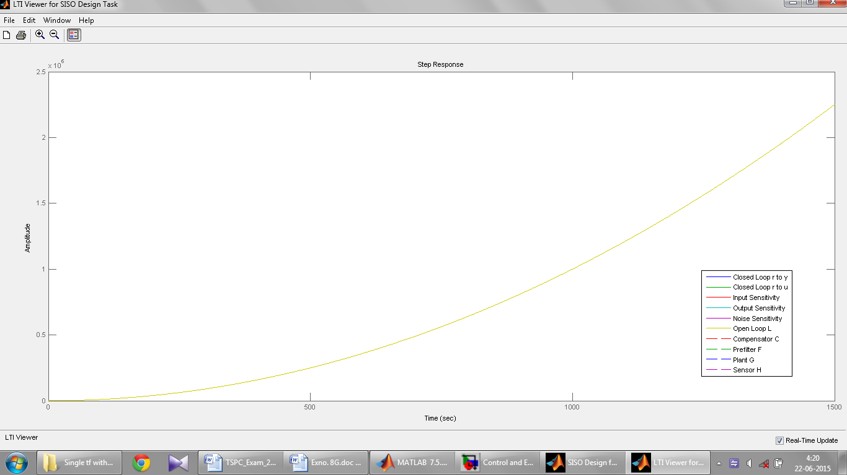

**The amplitude of the open-loop system is increasing with respect to time and it doesn’t reach the steady state value which will prolong for the long time and the system is unstable.**

1. plot the **closed-loop** dynamic response to a unit step change in *set point*, attach it here and give your comments

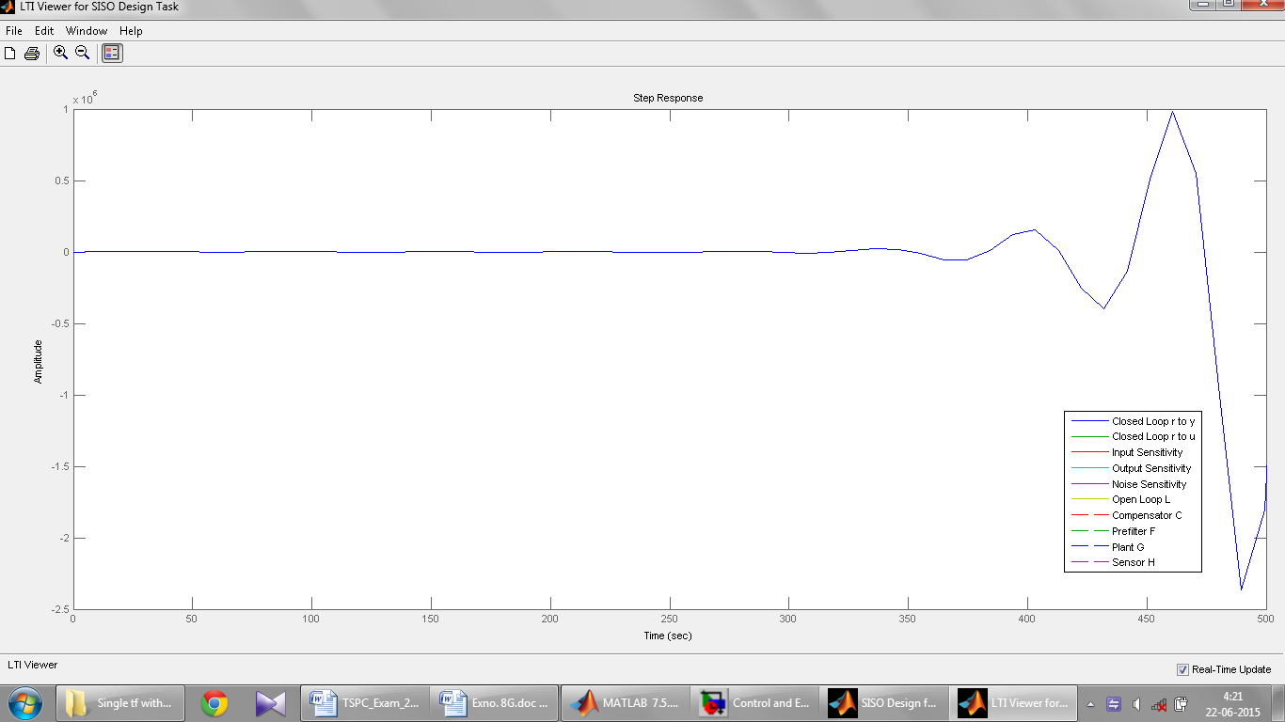

**The system does not reach a new steady state (an asymptotic value) for which it is unstable.**

## Part D:

= = =