Last name Ansanelli Name Rachele student ID No.:062200567
PC No. ____18_______

Section 4: STABILITY OF LINEAR DYNAMIC SYSTEMS
A dynamic process G(s) has the following 4 poles:
0
−0.05*(2*n+0.5)/(2*n−0.5)
−0.1
−2
the following 2 zeroes:
−1
−0.5*(2*n+0.5)/(2*n−0.5)
the following transfer constant:
1
where n = 18.
Transfer function:
s^2 + 1.514 s + 0.5141
----------------------------------------
s^4 + 2.151 s^3 + 0.3079 s^2 + 0.01028 s
>> zpk(G)

Zero/pole/gain:
(s+1) (s+0.5141)
--------------------------
s (s+2) (s+0.1) (s+0.0514)

- How much is the order?
The order of the system is four, as the degree of the denominator.
- How much is the type “g”?
The type is 1, as the number of poles in the origin.
- How much is the gain?
The static gain is the limiting value when s tends to zero and it is found on matlab by the command:
>> K=dcgain(G)

K =

Inf
- How many and how much are the time constants?
There are 5 time constants.
At the numerator: tauA=1 and tauB=1/0.5141 =1.9451
At the denominator: tau1=1/2=0.5, tau2=1/0.1=10 and tau3=1/0.0514=19.4553

- Is this an inverse response system?

No, it isn't, as it does not show any positive zero. It is also shown graphically by the command “step”:
The open loop response to a unit step does not show the typical pattern of an inverse-response.

Part A: Root locus
For the system Gp(s):

- Plot the root locus by means of Matlab and SisoTool resources and attach it here
It is attached above.
As the transfer constant k is greater than zero, direct root locus' rules must be used.
- Discuss and, if possible, calculate the asymptotes
There are q=n-m=4-2=2 asymptotes. They meet on the real axis on a point named center of gravity, whose abscissa is:
>> sigmaA=(sum(p)-sum(z))/2

sigmaA =

-0.3186
They also form two angles with the real axis which are evaluated, by using the direct root locus rules:
theta1=(2k+1)*pi/q=pi/2 with k=0
theta2=(2k+1)*pi/q=3pi/2 with k=1
k=0,...,q-1
- Calculate the value of the critical gain Kc*

The critical gain is the value at which the system becomes marginally stable, i.e. the poles are located on the imaginary axis.
This value is shown on sisotool, when trying to locate the poles on the imaginary axis, on the compensator editor:
Kc*=1.5896
- Discuss in detail the closed loop BIBO stability of the system when Kc is changed
The system may switch from stability to instability when varying Kc. As stated above, there is a limiting value for which the system is marginally stable.
For example, the system is stable for a Kc=3.4256

And it can be unstable with a Kc=0.12293

This is due to the imaginary axis crossing.

Part B: Frequency response
For the dynamic system G(s) and a P controller with Kc=1:

- Plot the Bode Diagrams by means of Matlab/SisoTool resources, with a log scale of the magnitude (NOT in dB), and attach them here
By the command “bode(G)” the plot is:

- Decide if the Bode stability criterion is applicable
The Bode stability criterion is not applicable when:
the open loop gain is negative;
the open loop system in unstable;
there is more than one crossover frequency.
In this case the phase passes through -180° twice(at 0,09rad/s and at 1 rad/s, as shown on the phase plot by right-clicking on the points) and then tends once again to this value asymptotically when omega tends to infinity.
By means of this, the criterion is not applicable.

- If yes, is the above system closed-loop stable?
It can't be checked by means of the Bode criterion.
- Plot and attach here the extended Nyquist diagram together with the unit circle and the Peak Response by means of Matlab and SisoTool resources, then discuss it in details
By the command “nyquist(G)” the plot is:
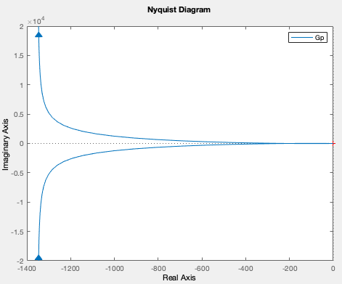
By the right mouse button commands “Zoom on -1”, “peak response” and “unit circle”
the plot added with these characteristics is:

By the right mouse button command “Properties”, and changing “Limits” several times to understand what happens whe zooming:

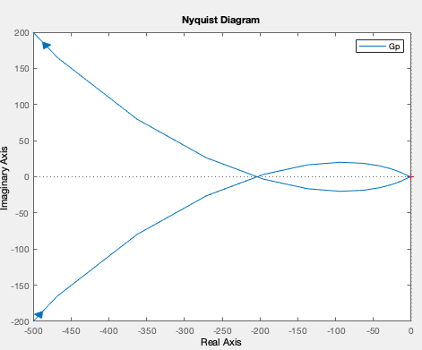

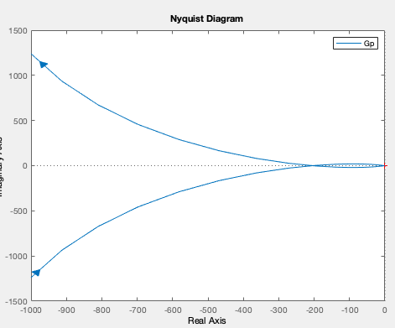

- Check, on the base of the Nyquist stability criterion, if the above system is closed-loop stable
First of all, the closure at infinity must be drawn on this plot, according to:

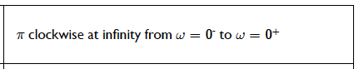

In this case N=number of times that the extended Nyquist plot encircles clockwise the critical point (-1,0) =1
P=number of poles laying on the RHP=0
Z=N+P=1>0 where Z is the number of unstable roots of the system.
If Z>0, the system is said to be BIBO unstable.
As we knew from the root locus, due to the imaginary axis crossing, the system is closed-loop unstable.

Part C: Dynamic responses in the time domain
- assign a suitable value to the controller gain Kc such as the system G(s) would be closed loop stable
Kc may assume infinite values in this system, but some of them may give closed-loop instability to the system, since the imaginary axis crossing occurs.
I decide to put the value previously evaluated at the point A.4
Kc=3.4256 that was at least a value giving open loop stability.
- plot the open-loop dynamic response to impulse, attach it here and give your comments

- plot the closed-loop dynamic response to a unit step in set point, attach it here and give your comments
- plot the closed-loop dynamic response to a unit step in disturbance, attach it here and give your comments
>> closed=feedback(G_new,1)
Transfer function:
3.45 s^2 + 5.224 s + 1.774
---------------------------------------------
s^4 + 2.151 s^3 + 3.758 s^2 + 5.234 s + 1.774
The system reaches a new steady state at a value of 0.5 which is typical of underdamped systems.
Part D: = = =

