June 18 2012 Exam
STABILITY OF LINEAR DYNAMIC SYSTEMS
A closed-loop dynamic system is made of PD controller
$$G_{\text{PD}}=\left(\frac{n}{4}s+1\right)$$
a purely algebraic final control element with G_{f} = 1,
a process G_{p} that is the result of 2 linear systems in series, each having the following transfer function
$G_{\text{rat}}=\frac{{\left(−1\right)}^{n}}{\left(\frac{n−0\text{.}5}{n+0\text{.}5}s^{2}+s+\frac{n+0\text{.}5}{n−0\text{.}5}\right)}$ $G_{\text{dt}}=e^{−\frac{n}{4}s}$
a measuring device with
$$G_{m}=\frac{1}{\left(s+\frac{n−0\text{.}5}{n+0\text{.}5}\right)}$$
where n = PC 4

>> gpd=tf([1 1],1)

Transfer function:
s + 1

>> grat=tf(1,[3.5/4.5 1 4.5/3.5])

Transfer function:
1
----------------------
0.7778 s^2 + s + 1.286

>> gdt=tf(1,1,'inputdelay',1)

Transfer function:
exp(-1*s) * (1)

>> gm=tf(1,[1 3.5/4.5])
Transfer function:
1
----------
s + 0.7778

>> gol=gpd*grat*gdt*gm

Transfer function:
s + 1
exp(-1*s) * ------------------------------------
0.7778 s^3 + 1.605 s^2 + 2.063 s + 1

I Draw the feedback control loop diagram
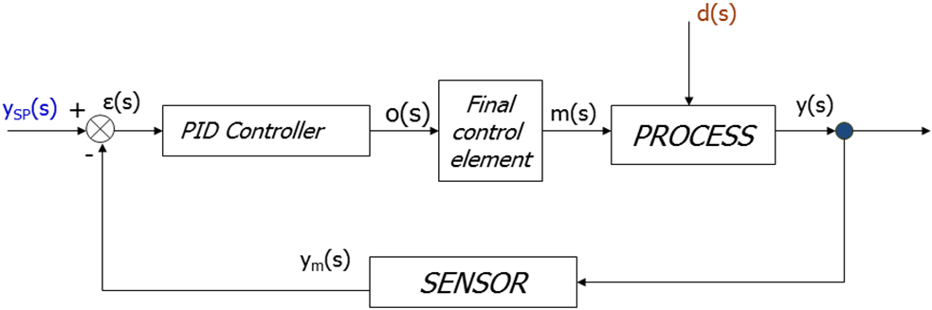
II What is the open-loop system order?
Definition: G_{OL}(s)=G_{PD}G_{rat}G_{dt}G_{m}
3°order.
III Is open-loop system an integrator process?
Answer: NO

IV How many and how much are the time constants?

>> zpk(gol)

Zero/pole/gain:
1.2857 (s+1)
exp(-1*s) * ---------------------------------
(s+0.7778) (s^2 + 1.286s + 1.653)

We have 3 time constants that are worth
1 = lead time constant (at the numerator)
1/0.7778=1.286 (at the denominator)
sqrt (1/1.653)=0.7778 (at the denominator)
V Is there any damping factor? If there is, how much is ζ ?
1.286/(2*0.7778*1.653)=0.5
VI How much is the open-loop system gain?
>> dcgain(gol)
ans =
1
The gain is equal to 1

Part A: Root locus
For the open-loop dynamic system with the exclusion of G_{dt}, plot the root locus by means of Matlab and SisoTool resources, attach it and answer here the following questions:

>> g=gpd*grat*gm
Transfer function:
s + 1
------------------------------------
0.7778 s^3 + 1.605 s^2 + 2.063 s + 1

- Determine poles, zeroes and No. of trajectories.
>> poly=pole(g)

poly =
-0.6429 + 1.1135i
-0.6429 - 1.1135i
-0.7778

>> zero=zero(g)

zero=
-1
The first rule of Evans says that the number of paths is equal to the number of poles of the transfer function in open loop, in this case, and then we have 3 trajectories
- Determine parts of root locus coincident with the real axis.
Through the command zpk (g) becomes the FdT in factored form in zeroes and poles of which there is a factor of k. From the sign of k it is realized whether to apply the direct or inverse rules of the place Evans.
>> zpk(g)

Zero/pole/gain:
1.2857 (s+1)
---------------------------------
(s+0.7778) (s^2 + 1.286s + 1.653)
k ≥ 0 induces a negative feedback and the rules to be applied are those relating directly to the site.
The knowledge of the portions of the real axis belonging to the place of the roots is easy from the definition of the third rule according to which Evans took a generic point on the real axis it belongs to the place of the roots if the right of this point there is an odd number of poles and zeroes.
In the presence of multiple poles and zeroes in q, the application of this rule they will be counted q times.
Having sketched out a map of the poles and zeroes that you belong to the root locus, the following portions: -1 < X <-0778
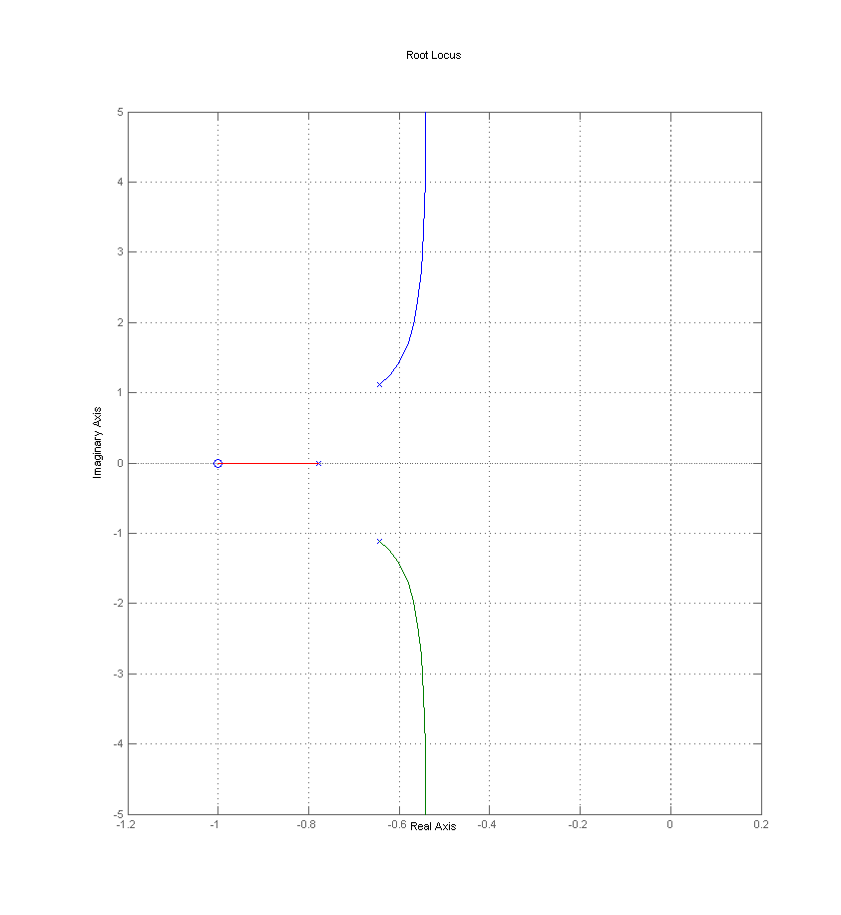
- Discuss existence of asymptotes and, if possible, calculate the gravity center and angles formed with the real axis.
There are n-m asymptotes (where n = order of the denominator of the transfer function; m = order of the numerator of the transfer function) for which the trajectories, having no zeroes corresponding on which end, there tend asymptotically tend to K of infinity
Angle 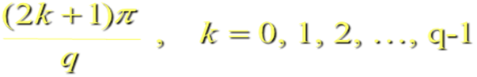
Intersection point( intercept ) calculated by :
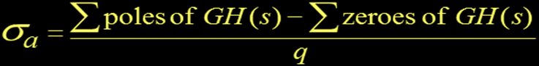

In this case we have n-m = 3-1 = 2 asymptotes whose center of gravity is given by:
range = (Σpi-Σzj) / n-m
Range >> = (sum (poles)-sum (zeroes)) / (3-1)
range =
-0.5317
The angle formed by these asymptotes with respect to the real axis is given by:
Theta = (2k +1) π / (n-m) with k = 0,1,2 ... n-m-1
π / 2 and 3π / 2

D) Discuss and, if possible, calculate starting and ending angles for poles and zeroes.
The poles have departure angles
$$ϑ=\frac{1}{q}\left[\left(2k+1\right)π+\sum^{m}{} | | n | \right]$$
Where k varies from 0 to q-1
q and v are the multiplicity of poles and zeroes, respectively.
>> Theta = (180/pi) * (1/1) * ((2 * 0 +1) * pi + sum (angle (poly (1)-zeroes))-sum (angle (poly (1)- poly)))
theta =
79.1253
>> Theta = (180/pi) * (1/1) * ((2 * 0 +1) * pi + sum (angle (poly (2)-zeroes))-sum (angle (poly (2)-poly )))
theta =
280.8747
>> Theta = (180/pi) * (1/1) * ((2 * 0 +1) * pi + sum (angle (poly (3)-zeroes))-sum (angle (poly (3)-poly )))
theta =
180

The zeroes have instead angles of arrival:
$$ϑ=\frac{1}{ν}\left[\left(2k+1\right)π+\sum^{n}{} | | m | \right]$$
Where k varies from 0 to q-1
q and v are the multiplicity of poles and zeroes, respectively.
>> Theta = (1/1) * (180/pi) * ((2 * 0 +1) * pi + sum (angle (zeroes (1)-poly))-sum (angle (zeroes (1)-zeroes )))
theta =180

- Discuss and, if possible, calculate the breakaway points

The angle of breakaway is 180°/k
Where k is the number of converging loci.
The location of the breakaway point is found from the solution of . The breakaway point is calculated by the V Evans rule
$$\sum_{i=1}^{m}{\frac{1}{s−\text{zi}}=\sum_{j=1}^{n}{\frac{1}{s−\text{pj}}}}$$
Points are acceptable only real results that lie on the root locus.
The trajectories depart or arrive at the point of breakaway at right angles to the real axis.
In our case there are no points of breakaway
Determine breakaway point : example 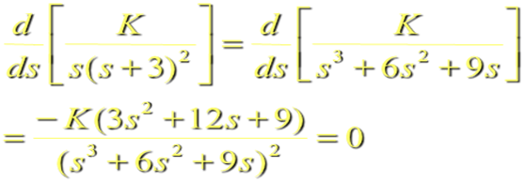 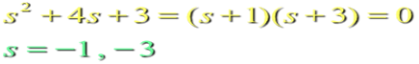

- Discuss the BIBO stability of the system when K_{c} is changed

The system is always stable regardless of the value of Kc.

- Calculate the limiting value/values for K_{c.}
There is a limit value of Kc. That means Kc at the imaginary axis

Part B Frequency response
For the open-loop dynamic system with G_{dt} included:
- Plot the Bode Diagrams by means of Matlab resources and attach them here
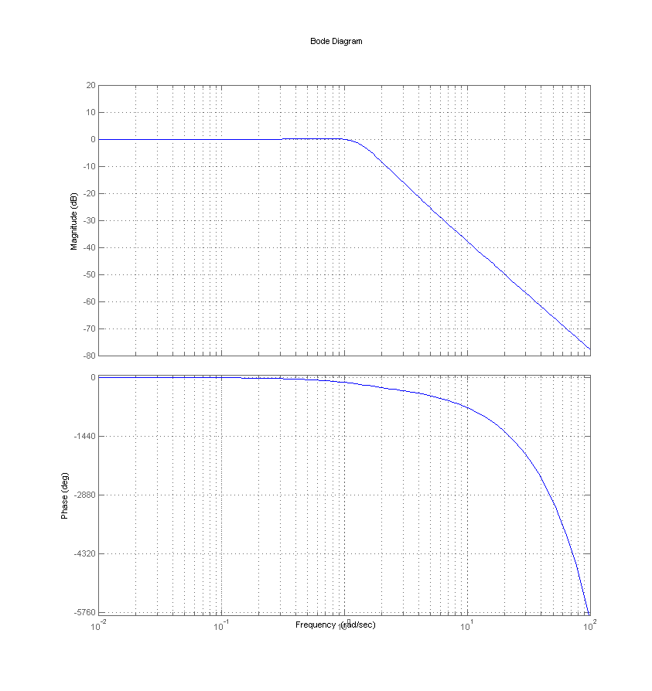
- Discuss the asymptotic behavior for low and high frequencies.
Low freq.: Magnitude → 0dB Phase →0
High freq.: Magnitude → -inf dB Phase → -inf

- Does a resonance frequency exist? How much is it?
The resonance frequency is the value of the frequency at which the peak occurs at resonance.
The resonance peak is the maximum value taken from the diagram of the amplitudes.
The resonance frequency is about 0.8 rad / s

- Does a crossover frequency exist? How much is it?
The crossover frequency is the particular value of the pulse which corresponds to a phase delay equal to -180 ° and applies at 1.35 rad / s.

- Does a gain crossover frequency exist? How much is it?
The crossing frequency gain (or gain crossover) is the value of that particular pulse which corresponds to a module AR unity/one and is worth about 0.28 rad / s

- Check, on the base of the Bode stability criterion, if the above system is closed-loop stable and calculate the gain margin.
Bode stability criterion: a feedback control system is BIBO unstable if AR FdT of the open loop is greater than 1 at the crossover frequency.
If there is no crossover frequency, the system is always stable.

The criterion does not apply when:
- The gain is negative
- The transfer function has poles positive real part
- The transfer function has zeroes positive real part
- The phase diagram (phi) shows more of a crossover frequency at phi = -180 °
- The diagram of AR show more crossover at AR = 1
Under this criterion, the system is stable.

The gain margin is defined as the change in the open loop gain required to make the system closed loop unstable. The gain margin is the difference between 0db and the point of the curve corresponding to the frequency of AR that there by a phase of -180 °.
Systems with high gain margin can withstand large changes in system parameters before becoming unstable closed loop.
From the Bode plot we see that the gain margin is about 1.26

- Plot the Nyquist Diagram by means of Matlab resources and attach it here
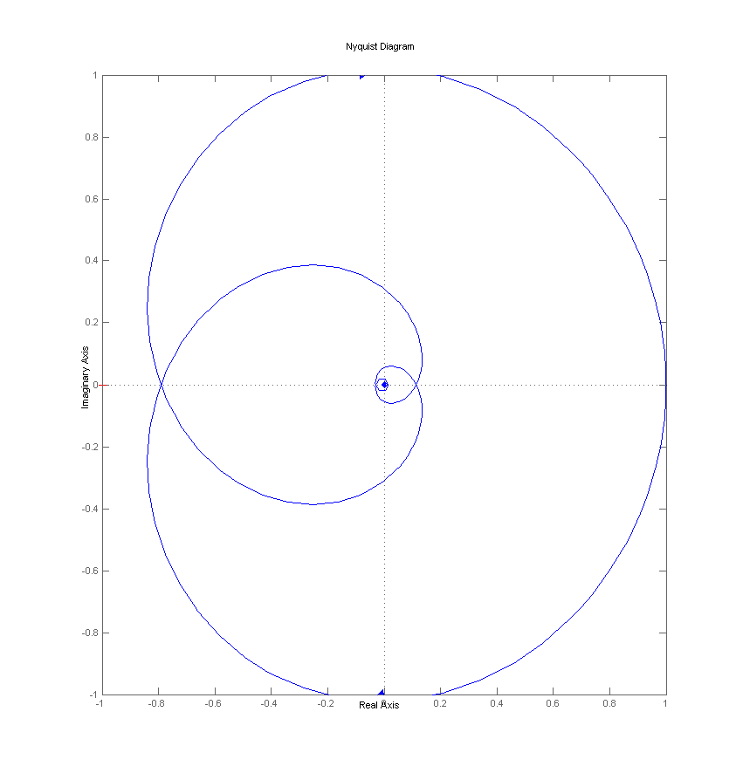
- Check, on the base of the Nyquist stability criterion, if the above system is closed-loop stable
On the basis of the Nyquist stability the feedback system is asymptotically stable if and only if the complete diagram of Nyquist accomplishes around the critical point -1 many turns counterclockwise how many are the poles positive real part and many half turns in the sense counterclockwise (even without surround the point -1) as the number of pure imaginary poles.
If the FdT open loop intersects the point (-1, 0) on the Nyquist diagram, there is a boundary condition of stability as AR = 1 and φ = -180 °.
Unlike the Bode stability criterion, the Nyquist criterion can also be applied to systems unstable in open loop.
Under this criterion, the system is stable.
- Calculate the phase margin
The phase margin is defined as the change in the open loop phase required to switch the system to a closed loop system unstable. It is the phase difference between -180 ° and the phase corresponding to the frequency that gives us a gain of 0dB, i.e. AR = 1.
This value is 146 °
- By changing K_{c}, calculate its limiting value

Part C: Dynamic responses in the time domain
For the open-loop dynamic system with G_{dt} included and with K_{c}=1:
- plot the open-loop and closed-loop system dynamic responses to a unit step change in set point by means of Matlab resources, attach them here and give your comments
- plot the open-loop process G_{p} response to a unit step change in disturbance by means of Matlab resources, attach here and give your comments.

Part D: Dead time compensator
The dead-time compensator is to eliminate the transport delay of the system.
Through the introduction of the Smith predictor, the process fetches a y ideal i.e an output from the process without delay. This output is sent to the dynamic block that represents the dead time. It generates a y process that corresponds to y ideal delayed by a dead time td. This must be subtracted to y ideal. After y ideal-y process adds ay (t) and everything is sent to the comparator that generates the error equal y set_point-(y-y process + y ideal). If the model correctly describes the process, (y process – y) = 0
Where: Gr (s) is the rational part of Gp.
t_{D} is the dead time
s + 1
G(r)= ------------------------------------
0.7778 s^3 + 1.605 s^2 + 2.063 s + 1
////////////////////////////////////////////////////////////////////////////

