Last name Carpentieri Name Serena student ID No.:
PC No. ____11_______

Section 4: STABILITY OF LINEAR DYNAMIC SYSTEMS
A dynamic process GP(s) with the following parameters:
Kp=(3n-0.5)/(3n+0.5)

has to be coupled with 2 different measuring sensors in a closed loop feedback control.
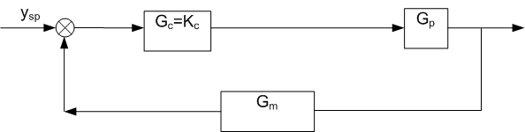

The 1st sensor has the following transfer function:

The 2nd sensor has the following transfer function:

Initially, Kc=1.

- Calculate and report here the open loop transfer function GOL1(s) by using Gm1(s)
- Calculate and report here the open loop transfer function GOL2(s) by using Gm2(s)
Gp=Kp*1/(tau^2*s^2+2*zita*tau*s+1)
Gp=((3*n-0.5)/(3*n+0.5))*(1/((2/3)*s^2+(2*(sqrt(2/5)*((2*n-0.5)/(2*n+0.5)))*sqrt(2/3)*s)+1))

Transfer function:
0.9701
-------------------------
0.6667 s^2 + 0.9869 s + 1
G_m1=((3*n-0.5)/(3*n+0.5))*(1/(s^2+1))

Transfer function:
0.9701
-------
s^2 + 1

>> G_OL1=Gp*G_m1

Transfer function:
0.9412
--------------------------------------------------
0.6667 s^4 + 0.9869 s^3 + 1.667 s^2 + 0.9869 s + 1

G_m2=((3*n-0.5)/(3*n+0.5))*((s-1)/((s+1)*(s+10)))

Transfer function:
0.9701 s - 0.9701
-----------------
s^2 + 11 s + 10

>> G_OL2=Gp*G_m2

Transfer function:
0.9412 s - 0.9412
------------------------------------------------
0.6667 s^4 + 8.32 s^3 + 18.52 s^2 + 20.87 s + 10

Part A: Root locus
For the system GOL1(s):

- Plot the root locus by means of Matlab and SisoTool resources and attach it here

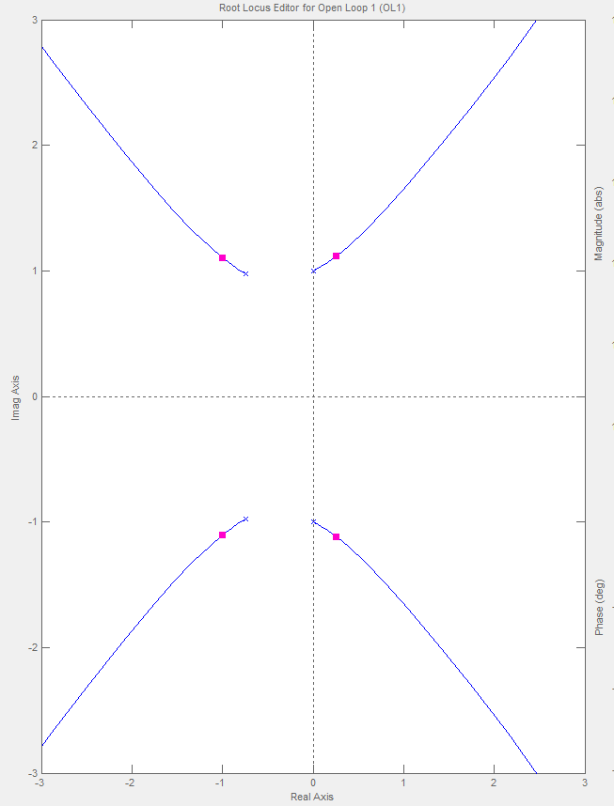

- Calculate the value of the critical gain Kc*
The Kc limit value can be read in the sisotool by moving the magenta cursors along the trajectories and stopping at the point of crossing the imaginary axis (marginal stability). Below this value of Kc the system is stable. In our case there isn't the limiting value of Kc.
- Discuss in detail the closed loop BIBO stability of the system when Kc is changed
The behavior of a dynamic system can be evaluated calculating the lim for t→∞ of its dynamic response. If this limit is bounded, and the forcing function is also bounded, the system is BIBO stable. Definition of BIBO Stability
An unconstrained linear dynamic system is said to be stable if the output response is bounded for all bounded inputs.
The stability of a dynamic system is determined through the poles of its TF in the Laplace domain (G(s)), such as the roots of the characteristic equation obtained putting the denominator equal to 0.
If such poles are located in the left half plain of the complex plain , from the antitrasformation of the response in the Laplace domain (y(s)) a bounded dynamic response (y(t)) is obtained.
In light of these considerations we can say that our system is stable until the gain Kc assumes such values ​​as to maintain the current values of closed loop transfer function poles (provided by matlab sisotool, purple points) in the negative half plain. The crossing of the imaginary axis is a symptom of the transition to an unstable state. In our case the system is always unstable.
For the system GOL2(s):

- Plot the root locus by means of Matlab and SisoTool resources and attach it here

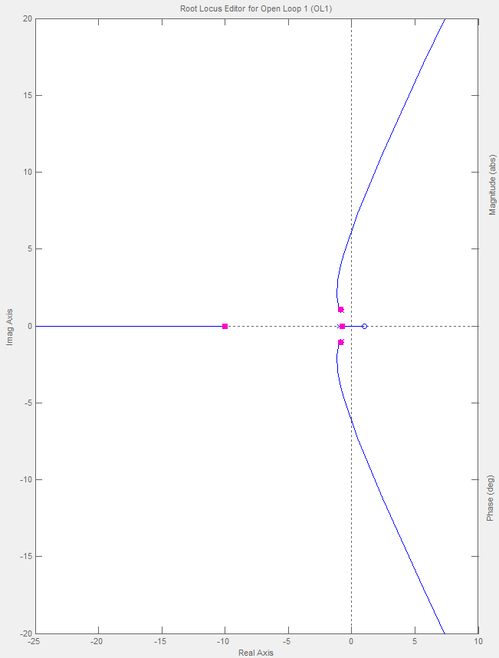

- Calculate the value of the critical gain Kc*
Kc*=9.94
- Discuss in detail the closed loop BIBO stability of the system when Kc is changed
We can say that our system is stable until the gain Kc assumes such values ​​as to maintain the current values of closed loop transfer function poles (provided by matlab sisotool, purple points) in the negative half plain. The crossing of the imaginary axis is a symptom of the transition to an unstable state. So the system is closed loop stable below Kc*.

On the basis of the above two Root Loci
- Discuss which measuring sensor is the most convenient to be adopted with the objective of closed loop stability
The most convenient measuring sensor to be adopted is the second, because according to the closed loop stability the first is always unstable.

Part B: Frequency response
For the system GOL1(s) and a P controller with Kc=1:

- Plot the Bode Diagrams by means of Matlab/SisoTool resources, with a log scale of the magnitude (NOT in dB), and attach them here
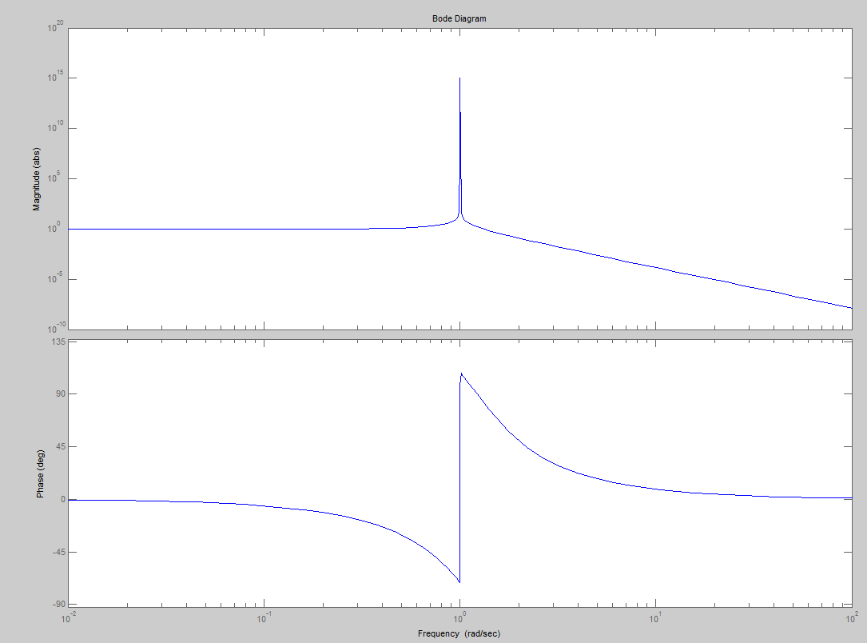

- Does one or more resonance frequencies exist? How much is the value?
There are two damping factors: zita=0 e zita=0.74
The abscissa of the max:

The existence condition of a max is:
that means z<0.707. So the resonance frequency exists only for zita=0.
Wr=1 rad/sec
G_zpk=zpk(G_OL1)

Zero/pole/gain:
1.4118
-----------------------------
(s^2 + 1.48s + 1.5) (s^2 + 1)

- Decide if the Bode stability criterion is applicable
Yes, it is applicable.
- If yes, is the above system closed-loop stable?
No, it unstable.
- Plot and attach here the extended Nyquist diagram together with the unit circle and the Peak Response by means of Matlab and SisoTool resources, then discuss it in details
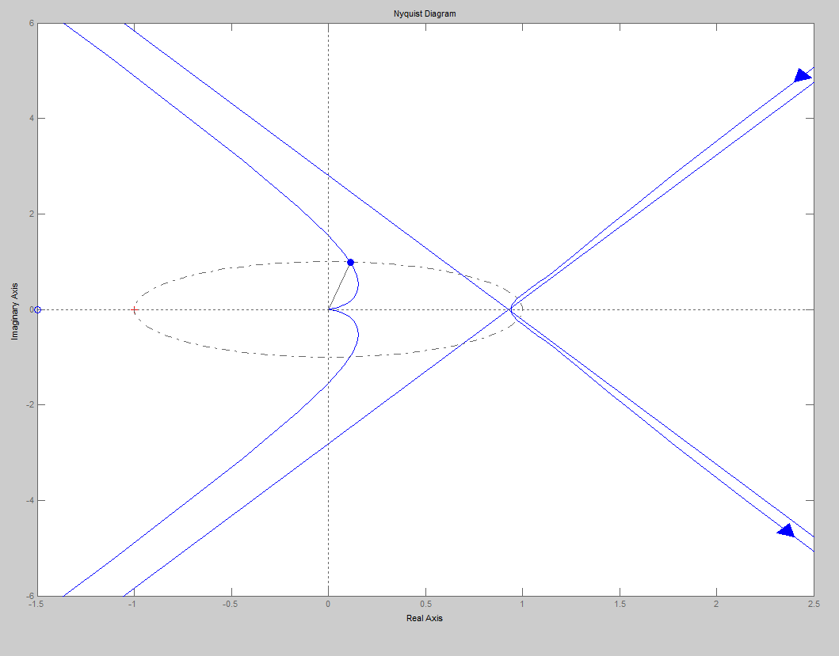

- Check, on the base of the Nyquist stability criterion, if the above system is closed-loop stable
Stephanopoulos’ formulation:
Most process control problems are open-loop stable. Consequently,
the closed-loop system is unstable if the extended Nyquist plot for G_{OL}(jω) encircles the -1 (critical point), one or more times.
Nyquist Stability Criterion:
General form
Nyquist Stability Criterion:
Given the closed-loop characteristic equation
1 + G_{OL}(s) = 0,
if N is the number of times that the extended polar plot of G_{OL}(jω) encircles the (–1,0) point in the clockwise direction as ω is varied from –∞ to +∞,
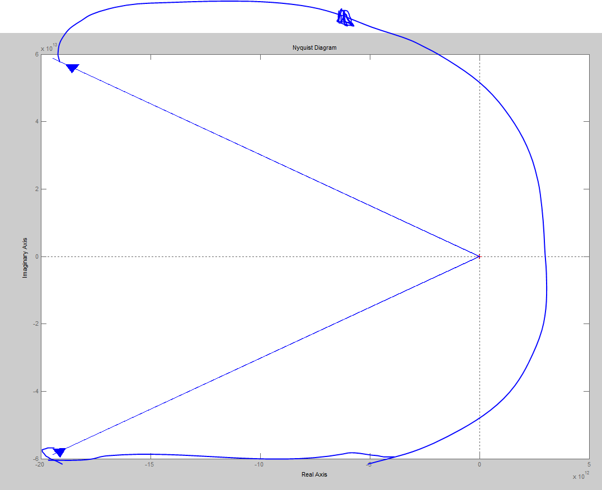
and if P≥0 is the number of the poles of G_{OL}(s) in the right half plane (RHP),
then Z = N + P is the number of unstable roots of the closed-loop characteristic equation.
In our case the system is not stable.
see the following Nyquist diagram:

Part C: Dynamic responses in the time domain
For the system GOL2(s) and a P controller with Kc=2.5:

- plot the open-loop dynamic response to impulse, attach it here and give your comments
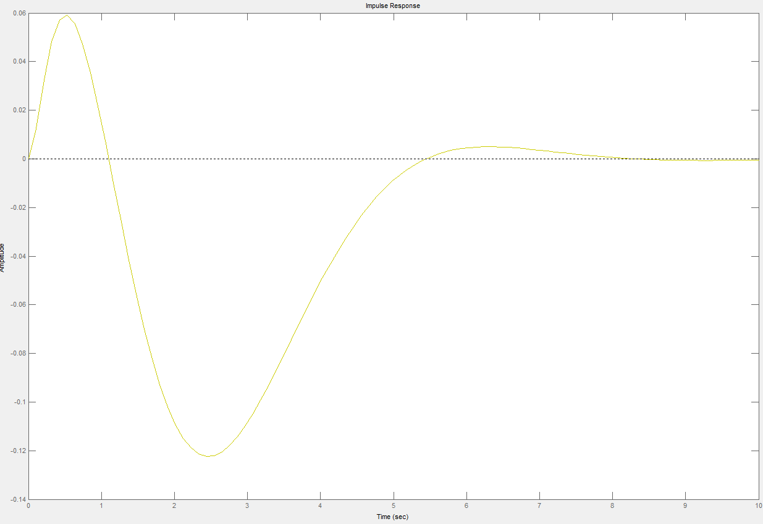
It is stable, because it tends to a steady state value after about 8 seconds.

- plot the closed-loop dynamic response to a unit step in set point, attach it here and give your comments
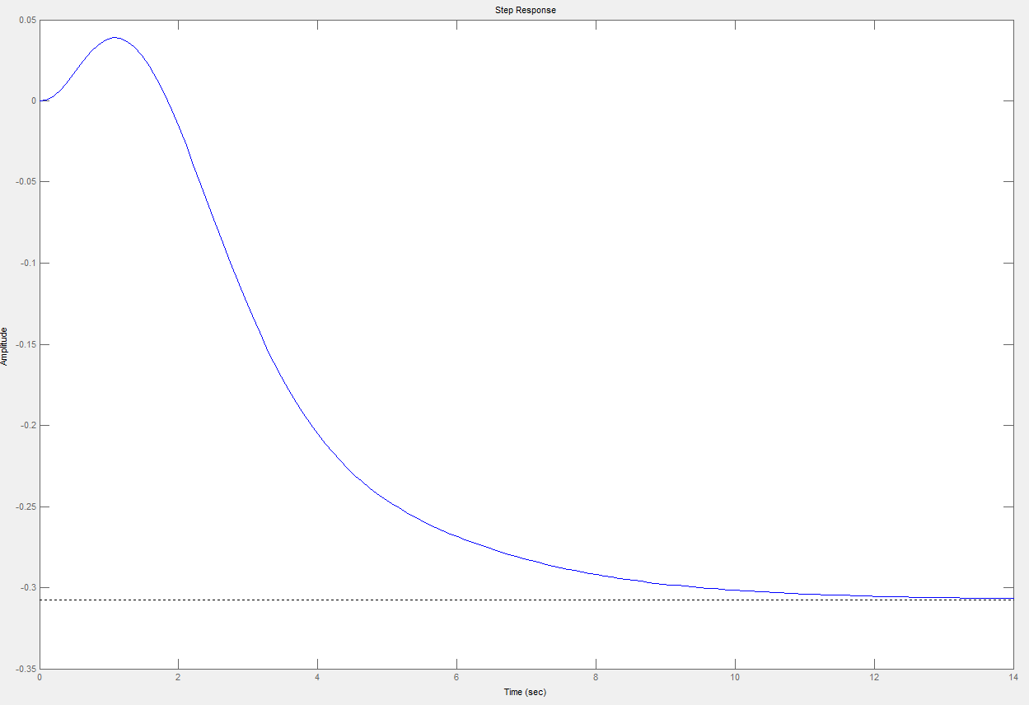

The closed loop dynamic response tends to a steady state value, so it is stable.

- plot the closed-loop dynamic response to a unit step in disturbance, attach it here and give your comments
This plot has the same trend of the closed loop dynamic response to a unit step in set point since it tends to a steady state value, so it is stable.

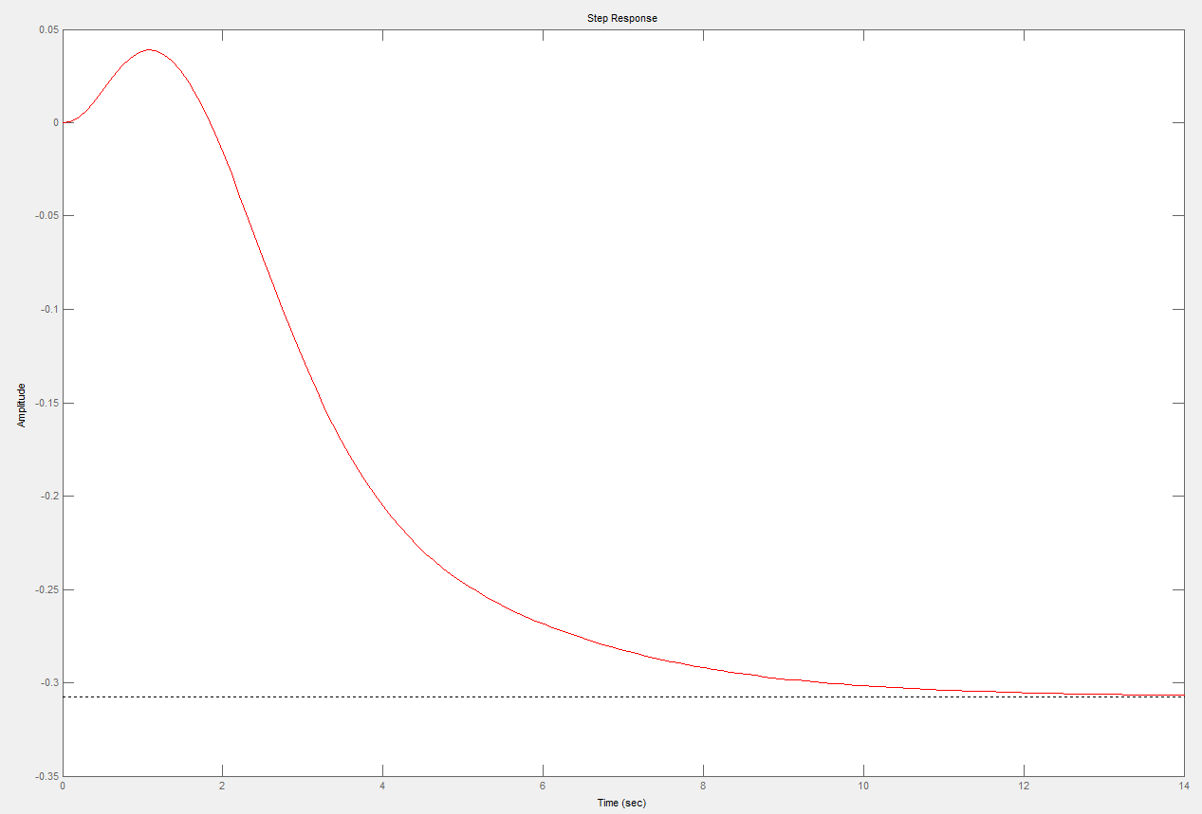

Part D:

= = =

