Last name FERRAIOLI Name Raffaella student ID No.:0622800264
PC No. 1

Section 4: STABILITY OF LINEAR DYNAMIC SYSTEMS
A dynamic process Gp(s) is made of 2 sub-systems in series having the following transfer functions

where n = PC No.

- Is Gp(s) an inverse response system?
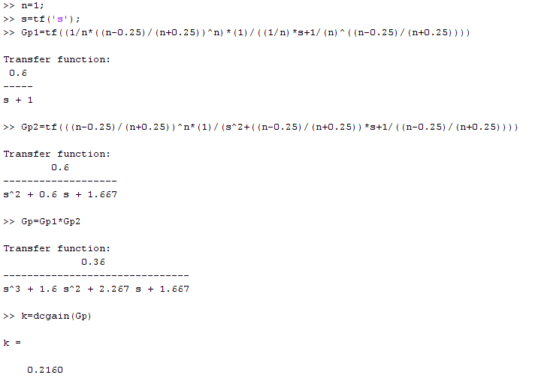

An inverse response system is a system with a negative gain. Computing the gain of the series we can observe that it has a positive value, for this reason it isn't an inverse response system.
We can have a proof of this thing using “step” and observing the plot that result:

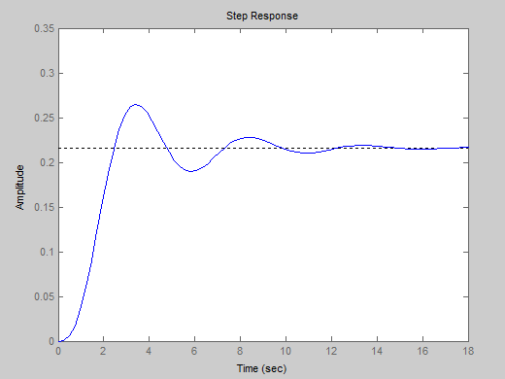
As we can see this isn't the typical plot an inverse response system.

- How much is type “g”?

The system obtained from the two TF in series has a g=0 because as we can see from the point I we don't have any pole in the origin.

- How much is the gain?

I obtain the gain with
>>K=dcgain(Gp)
and the value is:
K=0,2160

- How many and how much are the time constants?

We have in total 3 time constants giving by the number of poles (3 in this case) and the number of zeros (0 in this case).
We can compute them with:

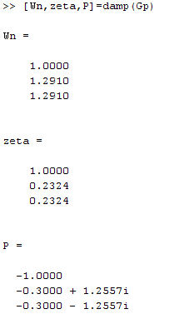

where Wn giving the inverse of the time constants, zeta are the damping factors and P are the poles of Gp. We can obtain the time constants just making the inverse of the Wn's values:

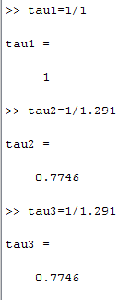

- How many and how much are the damping factors?

As we can see from the previous point, we have 3 damping factors :

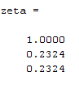
Part A: Root locus
For the dynamic system Gp(s):

- Plot the root locus by means of Matlab and SisoTool resources and attach it here

By means of: >>sisotool(Gp)

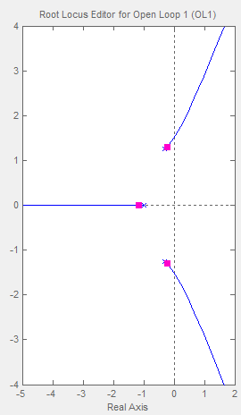
By means of >>rlocus(Gp)

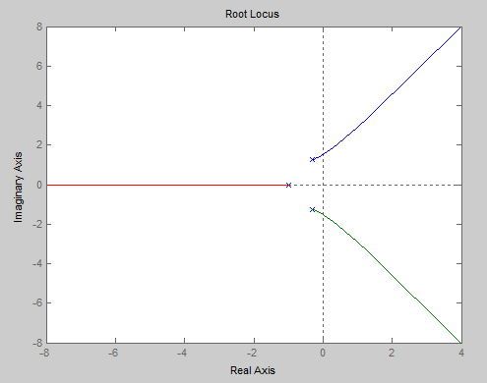
- Calculate the value of the critical gain Kc*

The value of the critical gain can be obtained just moving the square on the root locus plot (magenta on sisotool and black in rlocus) till the intersection with the imaginary axis. In this case the value is:
Kc*=5,38

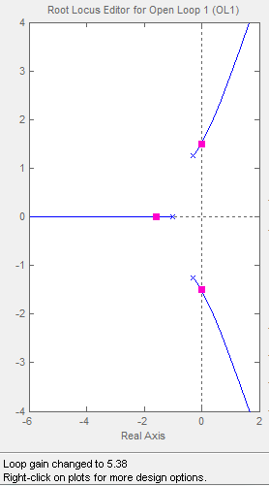
- Discuss in detail the closed loop BIBO stability of the system when Kc is increased from zero

The system is stable when the curve of the function stays in the left part of the plot that is the stable region, the imaginary axis is the limit between stability and instability because we have the passage from the stability region on the left side to the stable region on the right side. So we can say that for values of gain lower than the critical one the system is stable and for values larger than Kc* the system is unstable.

Part B: Frequency response
For the dynamic system Gp(s) and a P controller with Kc=1:

- Plot the asymptotic Bode Diagrams by means of the ASBODE script, and attach them here

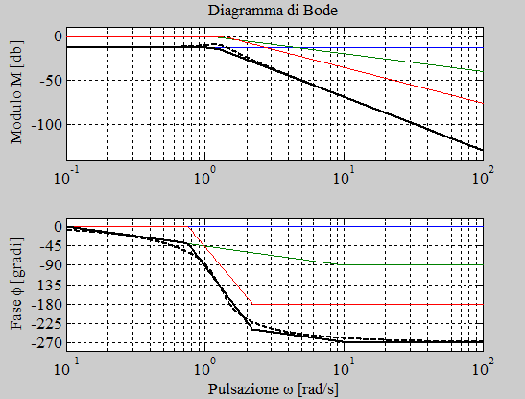

- Does one or more resonance frequencies exist? How much is the value?

Graphically, the resonance frequency exists when we have a maximum of the AR function, and in this case we have this maximum. We can read this value from the Bode diagram : is equal to 1

- Does a crossover frequency exist? How much is it?

We can evaluate the presence of the crossover frequency using:

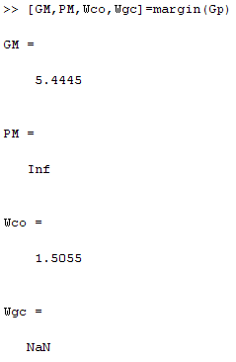

So the crossover frequency is 1,5055

- Does a gain crossover frequency exist? How much is it?

Yes, from the above step we can say that it doesn't exist

- Plot and attach here the extended Nyquist diagram together with the unit circle and the Peak Response by means of Matlab and SisoTool resources, then discuss it in details

with: >>nyquist(Gp)

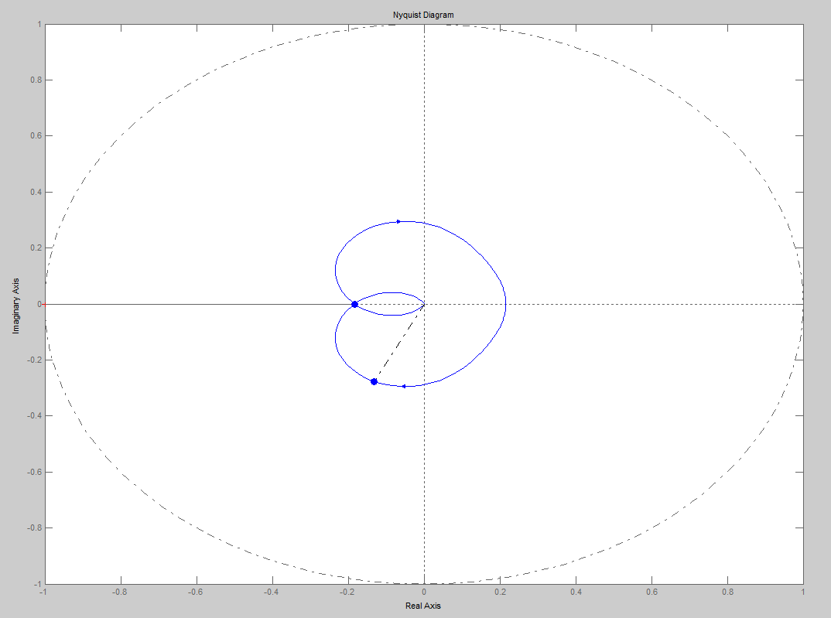

- Check, on the base of the Nyquist stability criterion, if the above system is closed-loop stable

In general, in order to verify, according the Nyquist stability criterion if the function is stable we need to do the closure at infinity because we want a closed curve but in this case the curve is already closed, so we just verify that the value of Z given by:
Z=N+P will be greater than zero
where N=number of times that the extended Nyquist plot encircles clockwise the critical point (-1,0)=0
P=number of poles laying on the RHP=0

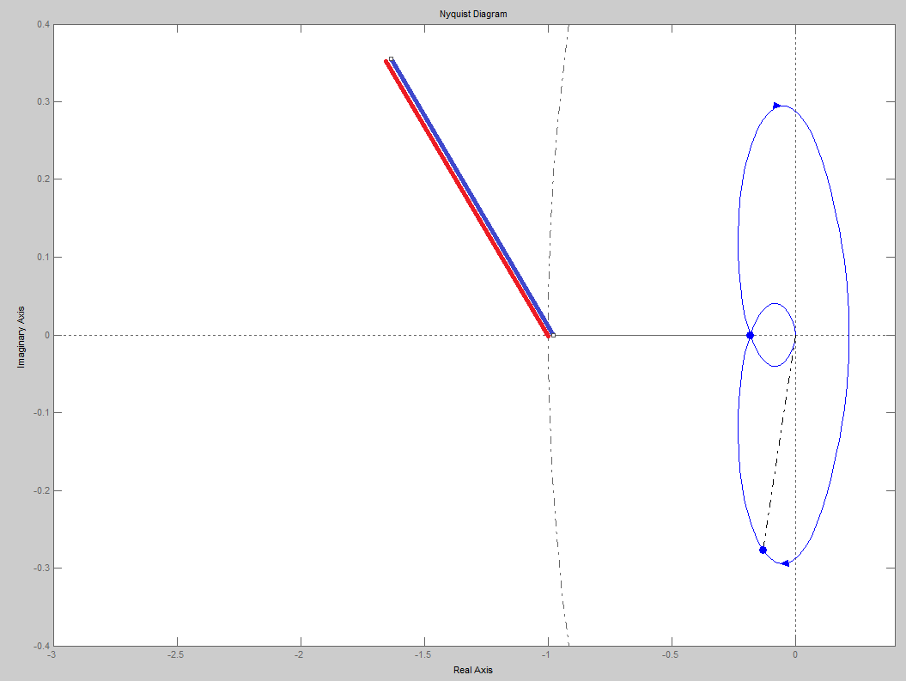
So Z=N+P=0+0=0 that isn't >0, for this reason, the system is unstable.

- Starting from the transfer function Gp(s) (and a P controller with Kc=1), propose a change such as the resulting new dynamic system Gpnew(s) has the extended Nyquist diagram passing through the critical point at −1 exactly

When the Tf pass through the critical point the system is asimpotically stable. This is an important point obtained from 1+Gol(s)=0 → Gol(s)= –1. If I want this new function without changing the poles, the only solution is changing the gain in order to transform the function in an asympotical stable function.

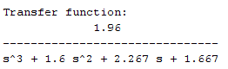

- Plot and attach here such a new extended Nyquist diagram together with the unit circle and the Peak Response demonstrating the crossing of the real axis at the critical point −1 exactly

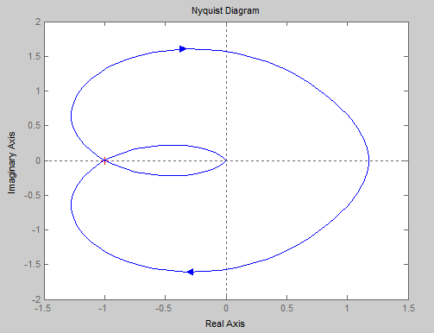

Part C: Dynamic responses in the time domain
For the system Gp(s):

- plot the open-loop dynamic response to unit step, attach it here and give your comments

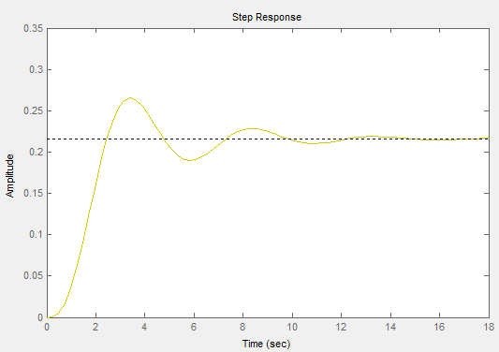

The system in able to reach a constant value about 16 seconds, so the system is able to be stable after this time.

For the system Gp(s) and a P controller with Kc=1:

- plot the closed-loop dynamic response to a unit step in set point, attach it here and give your comments

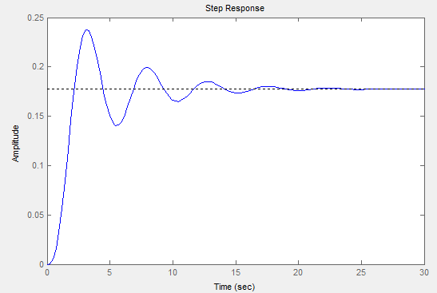

also in this case the system is able to became stable after a certain time but in this case it needs more time, in fact it is able to become stable just after about 25 seconds.

For the system Gpnew(s) and a P controller with Kc=1:

- plot the closed-loop dynamic response to a unit step in set point, attach it here and give your comments
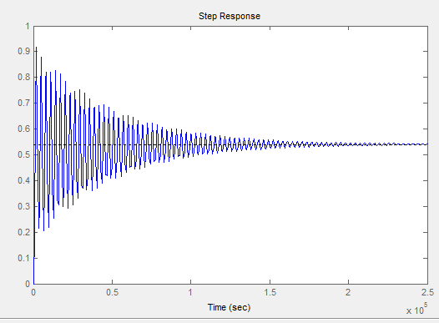
The function has a great disrbance at the beginning and needs a too long time in order to reach the stability

Part D:
= = =

