TSPC_Exam_2021-04-09

SOLVED QUESTIONS

Part C: Dynamic responses in the time domain

For the **dynamic system** Gp(s) that allows for closed loop stability as much as possible:

1. Plot the **open loop** **response** to a unit step **input** change**,**attach it here and give your comments

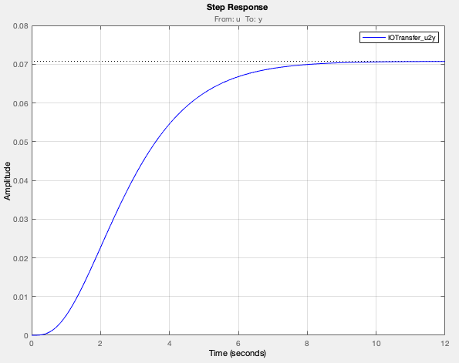

1. Plot the **closed loop** **response** yd(t) to a unit step **input** change in **disturbance,**attach it here and give your comments

1. Calculate the value of the **closed loop** **response** just yd(t) at a time equal to twice the smallest time constant in Gp(s)

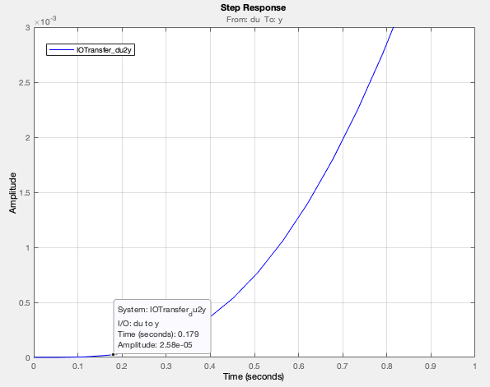

NEW QUESTIONS

1. asymptotic Bode

PLOT the asymptotic Bode with

asbode(NUM,DEN)

>> G_par1_zpk=zpk((n-0.05)/(n+0.05)/(s+1.25*(n-0.05)/(n+0.05))/(s+12.5*(n-0.05)/(n+0.05))/(s+p)^2)

G_par1_zpk =

            0.90476

  ---------------------------

  (s+11.31) (s+1.131) (s+1)^2

>> NUM=[.90476]

NUM =

    0.9048

>> DEN=[1 14.44 38.67 38.02 12.79]

DEN =

    1.0000   14.4400   38.6700   38.0200   12.7900

Questo modo di costruire i vett. NUM e DEN trasferisce valori "approssimati" dei coeff.

>> figure(1)

>> asbode(NUM,DEN)

Guadagno:        K =   0.071,   K_db = -23 db,     phi = 0 deg

Polo reale:      p = -11.309,   tau =   0.088,   1/|tau| =  11.309,   phi = da 0 a -90 deg

Polo reale:      p =  -1.131,   tau =   0.884,   1/|tau| =   1.131,   phi = da 0 a -90 deg

Poli complessi:  p,p' =  -1.000 +/- j  0.000,    omega_n =   1.000,   zeta =  1.00

                 beta = 10.0,                    omega_s =   0.100,   omega_d =  10.000,

                 phi = da 0 a -180 deg,          Delta M_db = -6 db

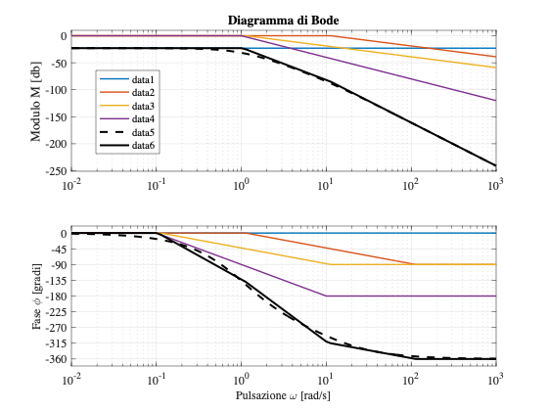

Use of the Symbolic Toolbox

>> syms x

>> DEN_par1=(x+1.25*(n-0.05)/(n+0.05))*(x+12.5*(n-0.05)/(n+0.05))*(x+p)^2

DEN_par1 =

(x + 1)^2*(x + 95/84)*(x + 475/42)

>> C=coeffs(DEN_par1, 'All')

C =

[1, 1213/84, 136433/3528, 33535/882, 45125/3528]

Questo altro modo di costruire i vett. NUM e DEN trasferisce valori "esatti" dei coeff.

>> NUM=(n-0.05)/(n+0.05)

NUM =

    0.9048

>> asbode(NUM,C)

Guadagno:        K =   0.071,   K_db = -23 db,     phi = 0 deg

Polo reale:      p = -11.310,   tau =   0.088,   1/|tau| =  11.310,   phi = da 0 a -90 deg

Polo reale:      p =  -1.131,   tau =   0.884,   1/|tau| =   1.131,   phi = da 0 a -90 deg

Polo reale:      p =  -1.000,   tau =   1.000,   1/|tau| =   1.000,   phi = da 0 a -90 deg

Polo reale:      p =  -1.000,   tau =   1.000,   1/|tau| =   1.000,   phi = da 0 a -90 deg

Cmq, usando il vett. C, asbode .... si BLOCCA nella costruzione del diagr. !