*Esempio preparato da Michele MICCIO Compito d'esame – Prova 2 del 10 giugno 2015*

## 6. MATHEMATICAL MODELLING

## Development of a dynamic mathematical model for a lumped-parameter system

A waste water transfer tank with continuous inlet and outlet is also equipped with an overflow pipe with diameter dof (see Figure).

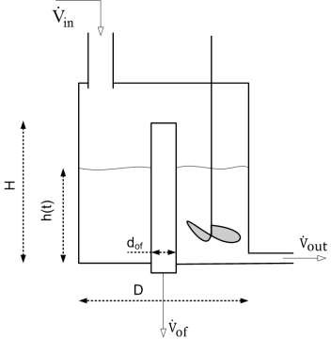Water enters from top through a supply pipe with flow rate in(t) and exits laterally on the bottom with flow rate $\dot{V}$ out (t).

The following hypotheses apply:

1. The hydrostatic head h (t) is always located at a level lower than the height of the overflow pipe H
2. The liquid surface can always be considered horizontal.
3. The density of the liquid ρ is constant
4. The flow rate of liquid at the outlet depends linearly on the hydrostatic head according to the law $\dot{V}$ o out (t) = h(t)/R with R= constant
5. The whole system is isothermal

You must:

1. Write a **steady state** model
2. write the **Dynamic mathematical model**, taking care to express in detail the volume V (t) of the liquid as a function of the level h (t)
3. take, if possible, the dynamic model in the canonical form in the time domain
4. classify the obtained dynamical model
5. list **input, state, output variables** and the **parameters** of the model
6. discuss which input variables can be assumed as **forcing functions** and which are their possible functional forms for this physical problem
7. write the model using the **deviation variables**
8. find the correspondent form of this **dynamical** model in the **Laplace domain**
9. write the **transfer functions G(s)**

As a further study, consider the case in which hypothesis 1) is no longer valid, and therefore the following 2 cases can occur (see Figure on the following page):

1. the overflow pipe has a diameter dof that is sufficient to function as overflow and effectively eliminates excess flow and maintains the constant level at the H value
2. the overflow pipe has a diameter dof that is insufficient to operate from overflow, therefore it determines an increase of the level h (t)> H and disposes a flow 𝑉̇𝑜𝑓 (t) = β[h(t)-H]

*file* modello_100615.docx pag. 1

You must:

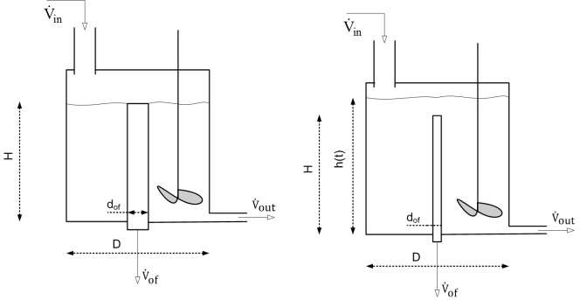

1. write the **material balance** for case I
2. write the **material balance** for case II
3. determine the **transfer function G (s)** for case I
4. determine the **transfer function G (s)** for case I

SOLUTION

## BASE CASE

1. **Balance of matter in stationary**

**b. Dynamic balance sheet**

In both cases the wastewater transfer tank with continuous input and output behaves exactly like the "variable level tank" and the overflow pipe (overflow pipe) does NOT work.

The general conservation law on the basis of which the subject balance is written is:

### IN – OUT = ACC

The volume of liquid in the term ACC, being for a liquid ρ = cost, is:

After steps ...

𝑉(𝑡) = 𝜋

𝐷2 4

ℎ(𝑡) − 𝜋

𝑑𝑜𝑓2

4

ℎ(𝑡) =

𝜋

[𝐷2 − 𝑑𝑜𝑓2]ℎ(𝑡)

4

CI: t = 0 h(0) = hs

…

the Fdt will be the classic one of the 1st order.

## Classification of the dynamic mathematical model thus obtained

* + Macroscopic
  + Described by a first-order ODE, linear, non-homogeneous, at coeff. steady

**d. Identification of input, status and output variables, as well as model parameters**

* + Input: 𝑉̇𝑖𝑛(t)
  + State: h(t)
  + Output: 𝑉̇𝑜𝑢𝑡(t)
  + Parameters: D, dof, H, R, β

**e. Input variables that can be taken as forcing and type functions**

* + •𝑉̇𝑖𝑛(t) can reasonably be ramped (limited!) or swinging (low frequency!)

**CASE I**

1. the overflow pipe is dof in diameter sufficient to function as overflow and effectively eliminates excess flow and maintains the constant level at the H value

In this case the wastewater transfer tank with continuous inlet and outlet "loses" the accumulation capacity of the "variable level tank" as the overflow pipe (overflow pipe) disposes of any possible variation of the inlet flow.

### The general conservation law on the basis of which the subject balance is written is:

### IN – OUT = 0

The Subject balance can be written ONLY in stationary.

Thus, the transfer function G (s) does NOT exist for case I

# CASE II

1. the overflow pipe is dof diameter insufficient to operate from overflow, therefore it determines an increase in the level h(t)>H and disposing a flow rate 𝑉̇𝑜𝑓 (t) = β[h(t)-H]

In this case the waste water transfer tank with continuous inlet and outlet "returns" to have a "variable level tank" type storage because the overflow pipe (overflow pipe) is insufficient to dispose of any possible variation of the entry flow.

### IN – OUT = ACC

The volume of liquid in the term ACC, being for a liquid ρ = cost, is:

𝑉(𝑡) = 𝜋

𝐷2 4

ℎ(𝑡) − 𝜋

𝑑𝑜𝑓′2

𝐻

The term ACC is expressed through the derivative $\frac{dV\left(t\right)}{dt}$ where, however,

the constant term ( $\frac{π}{4 }*d_{of^{'} }^{2}*H$) gives place to a null contribution to the derivative itself.

The term IN is obviously the forcing function 𝑉̇𝑖𝑛(t).

The term OUT is the sum of 2 discharge contributions from the bottom according to the linear outflow law:

𝑉̇𝑜𝑓 (t) +𝑉̇𝑜𝑢𝑡(t) = β[h(t)-H] + h(t)/R

After steps ...

CI: t = 0 h(0) = hs

…

the Fdt will be the classic one of **the 1st order.**